# Predicting toxin contamination in harvested marine species to guide dynamic ocean management

Christopher M. Free1*, Raphael M. Kudela2, Eric P. Bjorkstedt3,4, Lyall F. Bellquist5,6, Clarissa R. Anderson7

1 Bren School of Environmental Science and Management, University of California, Santa Barbara, Santa Barbara, CA

2 Department of Ocean Sciences, University of California, Santa Cruz, Santa Cruz, CA

3 Department of Fisheries Biology, Humboldt State University, Trinidad, CA

4 Southwest Fisheries Science Center, NOAA Fisheries, Santa Cruz, CA

5 The Nature Conservancy, San Francisco, CA

6 Scripps Institution of Oceanography, La Jolla, CA

7 Southern California Coastal Ocean Observing System, Scripps Institution of Oceanography, La Jolla, CA

**\* Corresponding author:** Bren School of Environmental Science and Management, University of California, Santa Barbara, Santa Barbara, CA; [cfree14@gmail.com](mailto:cfree14@gmail.com)

## Abstract (147 of 150 words)

Harmful algal blooms (HABs) produce toxins that accumulate in the tissue of seafood species and represent an increasing threat to seafood harvesters and consumers. Developing tools for predicting toxin contamination is critical to designing dynamic management strategies for mitigating risk to consumers while also minimizing impacts on harvesters. Here, we develop machine learning models for predicting daily coastwide domoic acid contamination in seven harvested marine invertebrates in California. Contamination in four wild capture species frequently exceeded management action thresholds. Models developed for these species were good predictors of contamination risk and hindcast high rates of contamination in historical catch. On the other hand, contamination in two aquaculture species rarely exceeded management action thresholds indicating that weekly testing and dynamic management have successfully eliminated public health risks for these species. We use our models to measure the appropriate spatial-temporal scales for toxin monitoring programs and dynamic fishery closures.

**Keywords:** harmful algal blooms; *Pseudo-nitzschia*; ecological forecasting; dynamic ocean management; climate change; domoic acid; machine learning; aquaculture; fisheries; biotoxins

## Introduction

Harmful algal blooms (HABs) represent an increasingly significant threat to fisheries and aquaculture around the globe. They have been increasing in size, frequency, duration, and toxicity due to the combined effects of eutrophication and climate change [(Glibert, 2020; Hallegraeff, 2010, 1993; Van Dolah, 2000)](https://www.zotero.org/google-docs/?qMDy9v) and these trends are expected to persist or worsen with continued climate change (“high confidence” in [(IPCC, 2019)](https://www.zotero.org/google-docs/?XTAh0U)). HABs produce toxins that accumulate in the food web, including in species harvested in fisheries and aquaculture, and can cause human illness or mortality when consumed in high doses [(Grattan et al., 2016)](https://www.zotero.org/google-docs/?0Z42A8). HABs can reduce revenues from fisheries and aquaculture due to fishkills, closures to limit public health risk, and costly monitoring programs and mitigation responses [(Hoagland et al., 2002; Hoagland and Scatasta, 2006)](https://www.zotero.org/google-docs/?Oj7fn2). Furthermore, HABs can reduce tourism revenue from recreational fisheries [(Dyson and Huppert, 2010)](https://www.zotero.org/google-docs/?sO3Ypj), food provisioning in subsistence fisheries [(Borbor-Córdova et al., 2018)](https://www.zotero.org/google-docs/?nuePpU), and disrupt cultural practices, community identity, and social interactions associated with fishing [(Bauer et al., 2010; Willis et al., 2018)](https://www.zotero.org/google-docs/?eobmKA).

The impact of HABs on human society can be reduced through prevention, control, and mitigation [(Anderson, 2009; Boesch et al., 1996)](https://www.zotero.org/google-docs/?H9HYe2). Although the prevention of HABs through reductions in nutrient runoff, pollution, and greenhouse gas emissions is optimal [(Paerl et al., 2018, 2016)](https://www.zotero.org/google-docs/?80hqZw), these pathways represent long-term projects that are outside the purview of fisheries and aquaculture managers and operators. Control (a.k.a., suppression or destruction) of HABs ~~through human interventions~~ has received limited consideration [(Anderson, 1997)](https://www.zotero.org/google-docs/?F3v0gL) due to unknown efficacy, low economic feasibility, and high potential for unintended consequences [(Anderson, 2012, 2009)](https://www.zotero.org/google-docs/?vFZfIF). This leaves mitigation as the most actionable real-time response available to seafood operators and managers. Current HAB mitigation measures [(Anderson et al., 2001)](https://www.zotero.org/google-docs/?nWYgUr) include: (1) temporary closure of fisheries and aquaculture facilities in areas with high contamination; (2) relocation of fishing grounds or aquaculture operations to uncontaminated areas; (3) depuration of toxic fisheries or aquaculture organisms in uncontaminated waters; or (4) evisceration of the most contaminated parts of the organism. Although these procedures have generally been effective at keeping contaminated seafood off the market [(Anderson et al., 2001)](https://www.zotero.org/google-docs/?OgWJBF), they can incur great economic and cultural costs to the people who depend on these resources [(Bauer et al., 2010; Dyson and Huppert, 2010; Mao and Jardine, 2020)](https://www.zotero.org/google-docs/?PATtBk).

The design of mitigation strategies that eliminate public health risks posed by HABs while also minimizing the burden placed on fishers and farmers depends on aa robust capability to detect and forecast the occurrence of HABs and accumulation of toxins in seafood species. Traditionally, the detection of HABs and seafood contamination has relied on *in situ* monitoring of phytoplankton community composition and toxin production and field collection of shellfish samples for lab contamination testing [(Stauffer et al., 2019)](https://www.zotero.org/google-docs/?vth2n6). Although these methods yield precise measurements of HAB and toxin dynamics, these programs are often opportunistic (i.e., not explicitly linked with an experimental design), costly, provide information on delay (i.e., after lab processing), and offer limited spatial and temporal resolution [(Stauffer et al., 2019)](https://www.zotero.org/google-docs/?wUfApS). Alternatively, statistical models that link *in situ* measurements with satellite observations and oceanographic model output can provide near real-time estimates of HAB dynamics at daily intervals on large spatial scales [(Anderson et al., 2019; Stauffer et al., 2019)](https://www.zotero.org/google-docs/?BtWJv2). Although predictions from these models are limited to the ocean surface and are less precise than *in situ* measurements [(Anderson et al., 2016; Stumpf et al., 2009)](https://www.zotero.org/google-docs/?ahB89B), they can provide early warning of HAB risk and guide dynamic ocean management, especially when interpreted in coordination with stakeholders [(Anderson et al., 2019)](https://www.zotero.org/google-docs/?ztIT6N).

However, surface densities of harmful algae and toxins are not necessarily correlated with the accumulation of toxins in benthic (and some non-benthic) organisms [(Kvitek et al., 2008; Sekula-Wood et al., 2011; Umhau et al., 2018)](https://www.zotero.org/google-docs/?KMHOJa), which is the ultimate concern for managers and often the metric that triggers management action [(US-FDA, 2019)](https://www.zotero.org/google-docs/?trhjkI). Thus, a critical next step in the development of predictive modeling tools is to translate maps of near real-time surface HAB and toxin risk into maps of near real-time seafood contamination risk [(Anderson et al., 2019)](https://www.zotero.org/google-docs/?LZMXkl). This has been challenging because the processes governing the uptake, retention, and depuration of toxins in aquatic food webs are highly complex [(Granéli and Turner, 2006)](https://www.zotero.org/google-docs/?InOdae). For example, toxic algae cells can accumulate in benthic sediments, be resuspended via bioturbation currents, and triggercontamination events well after the termination of the original bloom [(Vigilant, 2007)](https://www.zotero.org/google-docs/?DnLyH4). While mechanistic models for describing, predicting, and forecasting these complex processes evolve [(CA-OST, 2016a; NOAA, 2015; Stauffer et al., 2019; Terseleer et al., 2013)](https://www.zotero.org/google-docs/?KntL0i), statistical models employing state-of-the-art machine learning could provide mechanism-free approaches for predicting benthic seafood contamination from surface HAB and toxin dynamics. In this study, we evaluate the ability for machine learning models to predict toxin contamination in seven important harvested marine invertebrates in coastal California.

In California, blooms of diatoms in the *Pseudo-nitzschia* genus are linked to warm ocean conditions [(McKibben et al., 2017)](https://www.zotero.org/google-docs/?xFFkR0) and produce domoic acid, a neurotoxin that accumulates in the tissue of important seafood species [(Lefebvre et al., 2002)](https://www.zotero.org/google-docs/?a6USgA) and causes amnesic shellfish poisoning in humans when consumed in high doses [(Perl et al., 1990)](https://www.zotero.org/google-docs/?07E1Lx). In 2015, an especially large bloom of *Pseudo-nitzschia* resulted in the prolonged closure of important commercial and recreational fisheries and aquaculture along the entire U.S. West Coast [(McCabe et al., 2016)](https://www.zotero.org/google-docs/?YIoNdN). The direct economic impact from commercial closures was estimated to be $25.6 million for the California Dungeness crab and rock crab fisheries ([(CDFW, 2018)](https://www.zotero.org/google-docs/?WyzRg7); the value of federal disaster relief funds issued to the state) with substantial but unquantified impacts to other commercial, recreational, and aquaculture fisheries [(Moore et al., 2019; Ritzman et al., 2018)](https://www.zotero.org/google-docs/?xunPS2). While aquaculture facilities are required to test for domoic acid weekly and have a clear domoic acid management plan [(CDFW, 2017a)](https://www.zotero.org/google-docs/?ZdLU11), the monitoring and management of domoic acid in capture fisheries is more limited. Despite the importance of the Dungeness crab fishery and the consequences of its closure on the state economy, the biotoxin monitoring program that triggers these closures is limited to 72 individual pre-season crab samples divided among six sampling sites coastwide [(CA-OST, 2016b; PSMFC, 2018)](https://www.zotero.org/google-docs/?RVWNlu). The sampling program for other wild species is ad-hoc, voluntary, and unfunded [(CA-OST, 2016b)](https://www.zotero.org/google-docs/?HWK7x4).

In this study, we develop state-of-the-art machine learning models for predicting domoic acid contamination in seven commercially or recreationally important marine invertebrates in California (**Table 1**). The models relate predictions of daily surface water domoic acid risk from the California Harmful Algae Risk Mapping system (C-HARM; (Anderson et al., 2016)) (**Figure 1; Figures S1-S2**) to the domoic acid contamination of crabs and bivalves sampled by the California Department of Public Health (CDPH; (CDPH, 2019)) as part of its marine biotoxin monitoring program (**Figures 1-3**). By leveraging the spatial and temporal domain of the C-HARM system, our models can provide daily hindcasts (March 5, 2014 to present), daily nowcasts, and 3-day forecasts of domoic acid contamination on a 3-km grid spanning all of coastal California. We illustrate how our models could be used to: (1) guide studies into the biology of domoic acid accumulation in the food web; (2) identify low risk sites for aquaculture farms; (3) evaluate appropriate spatial-temporal scales for dynamic closures; and (4) build operating models for simulation testing of candidate strategies for dynamic ocean management.

## Results and discussion

Four of the five species that support capture fisheries -- Dungeness crab, rock crab, spiny lobster, and razor clam -- exhibited high rates of domoic acid contamination above their FDA action thresholds (15-80% of samples; **Figure 3**) and the best performing models for these species were fair to good predictors of domoic acid contamination risk (**Figure 4; Table S1**). California sea mussel was the only wild-harvested species to exhibit low rates of contamination above its action threshold (3.4% of samples; **Figure 3**) and models for this species were poor predictors of domoic acid contamination risk (**Figure 4; Table S1**). For the four capture species with adequate models, we hindcast historical contamination risk inside fishing grounds from 2014 to present (**Figure 5**). We used these hindcasts to characterize the spatial and temporal variability of historical contamination events and provide guidance on (1) where expansions in field monitoring could improve ability to detect and monitor contamination events and (2) the appropriate size and duration of fishery closures in response to domoic acid contamination events.

The routine pre-season monitoring of domoic acid contamination in Dungeness crabs has relatively good spatial coverage from Monterey Bay north (**Figure 5**), where approximately 97% of Dungeness crab landings have been caught over the past five years (**Figure SX)**. As a result, pre-season monitoring has successfully detected and tracked many of the historical early season contamination events predicted by the model (**Figure 5**). However, sampling has been limited south of Monterey Bay despite high predicted domoic acid risk in this area (**Figure 5**). Although this area generates only a small portion of state-wide landings (~3%), it is the source of catch for the majority of Dungeness crab landed in Avila Beach/Port San Luis and Morro Bay, and may disproportionately expose these communities to domoic acid risk (**Figure SX**). Furthermore, the model predicts that a number of late season contamination events went undetected following the termination of pre- or early-season testing. Although the majority of the catch in this derby fishery is caught at the beginning of the season (**Figure SX**), unmonitored late season catch still presents a public health risk. Overall, the largest benefits for public health might be the expansion of pre-season monitoring south of Monterey Bay and routine late season monitoring coastwide whereas the largest benefits for fishers, via more nimble management, might be the expansion of early-season monitoring between Eureka and Bodega Bay (**Figure 5**).

Historically limited monitoring of rock crab and spiny lobster for domoic acid contamination is likely to have overlooked a number of large contamination events. This is particularly true for spiny lobster, for which sampling has been sparse, yet is predicted to have experienced extensive contamination risk (**Figures 5&6**). In six years, only 173 spiny lobster have been tested for domoic acid contamination (**Figures 2&3**) and the majority of these samples (95%) were collected during three sampling campaigns (**Figure 5**). This limited sampling program likely overlooked extensive contamination events occurring north of Los Angeles (34°N), especially during the 2016-17, 2017-18, and 2018-19 seasons (**Figure 6**). However, the timing of the commercial and recreational lobster season (Oct 1-Mar 15) does reduce contamination risk, with more pronounced contamination events occurring in the off-season summer months than during in-season winter months (**Figures 5&6**). Rock crab were predicted to experience frequent contamination events but at smaller spatial and shorter temporal scales than either Dungeness crab or spiny lobster (**Figures 5&7**). The rapid turnover in rock crab contamination events constrains the feasibility of dynamic management in this fishery (citation). Domoic acid closures for rock crab may be necessarily less nimble and more precautionary than for Dungeness crab or spiny lobster.

Razor clams, which exhibit slow domoic acid depuration rates [(Schultz et al., 2008)](https://www.zotero.org/google-docs/?OSHfOG) and can retain domoic acid for up to a year after a HAB event [(Wekell et al., 1994)](https://www.zotero.org/google-docs/?aFBtSG), were predicted to have the highest frequency and intensity of historical contamination events (**Figures 6-8**). In response to this risk, the California Department of Fish and Wildlife (CDFW) has closed the recreational razor clam fishery since April 2016 in Humboldt and Del Norte counties [(CDFW, 2017b)](https://www.zotero.org/google-docs/?gl1uBX), which are home to Clam Beach and Crescent Beach, respectively (**Figure 2**), the two most productive, popular, and well-monitored clamming beaches in the state [(Moore, 2001)](https://www.zotero.org/google-docs/?tF98CQ). The CDFW currently recommends that clammers visit Doran Beach in Sonoma County and Dillon Beach in Marin County while the closure remains in place [(Wilson, 2017)](https://www.zotero.org/google-docs/?JQDMHa). However, these beaches have received little to no monitoring (**Figure 2**) and contamination at these beaches has likely been high since 2014 (**Figure 5**). Our model predictions could be used to identify low risk razor clam beaches that -- following validation through targeted field sampling and laboratory testing -- could be recommended for recreational clamming.

Our hindcasts of historical contamination risk could be used to compare the performance of alternative strategies for mitigating the impact of HABs on fisheries and public health through a process called management strategy evaluation. A management strategy evaluation (MSE) simulates the entirety of the resource--harvester--management loop to measure the performance of and tradeoffs between alternative management strategies [(Punt et al., 2016)](https://www.zotero.org/google-docs/?CEBLiL). As an example, our hindcasts could be used to simulate domoic acid contamination and to quantify the ability of alternative management strategies to maximize fishing opportunities (e.g., amount of catch or profits, length or timing of season, etc.) while minimizing contaminated catch (i.e., amount above the action threshold). The evaluated management strategies could include combinations of: (1) expanded or redesigned monitoring programs; (2) management triggers based on monitoring or other indicators of elevated risk; and/or (3) management actions such as fishery closures, evisceration orders, or timing of the open season. The MSE process can also incorporate other, potentially, synergistic, fishery risks. For example, delays in the Dungeness crab and rock crab trap fisheries due to domoic acid risk during the 2015-16 fishing season resulted in greater overlap in areas of high fishing effort and high humpback whale density, which resulted in a sharp increase in the number of whale entanglements in crab fishing gear [(Santora et al., 2020)](https://www.zotero.org/google-docs/?CeHWx9). Solutions to these interconnected management challenges could be explored by jointly simulating domoic acid contamination, humpback whale distributions, and crab fleet dynamics in a management strategy evaluation framework.

Both aquaculture species -- Pacific oyster and bay mussel -- exhibited low rates of domoic acid contamination above the FDA action threshold (<4% of samples; **Figure 3**) and models of contamination risk were either unreliable or impossible to estimate. No Pacific oyster samples exceeded the action threshold (the highest observed domoic acid contamination was 9.6 ppm; **Figure 3**) and contamination risk models were not pursued for this species. Only 3.3% of bay mussel samples exceeded the action threshold and models for these species were poor predictors of contamination risk (**Figure 3; Table S1**). The low rate of contamination in aquacultured organisms is likely driven by fast depuration rates (<96 hours) in these species [(Blanco et al., 2002; Mafra et al., 2010; Novaczek et al., 1992; Schultz et al., 2008)](https://www.zotero.org/google-docs/?Mzrk6T), and the frequent testing and dynamic management employed by aquaculture farms in collaboration with the CDPH. All commercial shellfish facilities are required to submit weekly tests to the state, conduct even more frequent testing on their own, and shutdown sales when individuals test above the FDA action threshold [(CA-OST, 2016b)](https://www.zotero.org/google-docs/?XE4bwj).

Although the lack of high domoic acid contamination in aquaculture species is good at face value, the absence of a robust contamination signal prevents the development of predictive models that could otherwise be used to give farmers advance warning of contamination events and identify low risk sites for new aquaculture farms. The use of sentinel organisms, i.e., the experimental placement of aquaculture species in areas representative of potential farm locations [(Backer and Miller, 2016)](https://www.zotero.org/google-docs/?gD8BBG), would advance the collection of data required to develop effective models for predicting contamination for existing or emerging aquaculture species. Aquaculture is the fastest growing food sector in the world [(FAO, 2018, 2016)](https://www.zotero.org/google-docs/?4VZO8L) and is likely to become an increasingly important source of food as the human population and its demand for animal-based protein grows [(Costello et al., 2019)](https://www.zotero.org/google-docs/?D49KOW). The ability for aquaculture to meet these demands will be challenged by increasing HAB frequency, storm intensity, ocean warming, salinity fluctuations, deoxygenation, and ocean acidificiation [(Barange et al., 2018; IPCC, 2019; Weatherdon et al., 2016)](https://www.zotero.org/google-docs/?TuDg3e). Thus, developing tools for identifying locations for aquaculture farms that are subject to minimal risk will be necessary for expanding aquaculture under climate change [(Gaines et al., 2019)](https://www.zotero.org/google-docs/?f0Oepy).

Our framework for predicting and forecasting seafood contamination risk ~~from estimates of HAB or toxin risk using machine learning models~~ is transferable to existing marine and freshwater biotoxin monitoring programs (see [(Anderson et al., 2019)](https://www.zotero.org/google-docs/?73nTy2) for examples) as the basis for statistical “shortcuts” while more mechanistic models for predicting the production and flow of toxins through the food web are developed and tested. For example, the machine-learning techniques developed here could be applied to relate brevetoxin contamination in wild and aquaculture shellfish [(Pierce and Henry, 2008)](https://www.zotero.org/google-docs/?5mFVop) to gridded predictions of *Karenia brevis* risk produced by the Gulf of Mexico Harmful Algal Bloom Operational Forecast System (GOM HAB-OFS; [(Stumpf et al., 2003; Tomlinson et al., 2004)](https://www.zotero.org/google-docs/?5CN6Vm)). In places without gridded predictions of HAB or toxin risk, contamination in seafood species could instead be predicted from more common data, such as field measurements of HAB or toxin densities or field or satellite measurements of the oceanographic processes driving HAB and toxin dynamics. [(Finnis et al., 2017)](https://www.zotero.org/google-docs/?hejjnC) provide a good example of the ability for machine learning models to predict toxin contamination from underlying oceanography. They show that contamination of mussels (*Mytilus* spp.) with saxitoxin, a neurotoxin produced by dinoflagellates in the genus *Alexandrium* that can cause paralytic shellfish poisoning, can be predicted from environmental variables such as temperature, salinity, and freshwater discharge.

The use of predictive statistical or mechanistic models to guide the dynamic management of domoic acid contamination could dramatically reduce the burden of closures on fishers and aquaculture farmers without increase (or even with a decrease) in the public health risk of contamination events. The economic benefits of such advancements are highly likely to outweigh the costs of expanded monitoring, data sharing platforms, and personnel required to develop and maintain these tools [(Stauffer et al., 2019)](https://www.zotero.org/google-docs/?Baa7In). Although the economic impacts of HABs are challenging to estimate [(Sanseverino et al., 2016)](https://www.zotero.org/google-docs/?kIvHkb), a recent evaluation suggests that marine and freshwater HABs result in approximately US$10 billion of economic losses annually [(Bernard et al., 2014)](https://www.zotero.org/google-docs/?w1qHNd). Given the rule-of-thumb that the value of information on a resource is worth at least 1% of the resource [(Macauley, 2006)](https://www.zotero.org/google-docs/?UvQxYU), annual investments in HAB monitoring, forecasting, and communication of at least US$100 million annually are warranted [(Stauffer et al., 2019)](https://www.zotero.org/google-docs/?Glkgmz). The importance of and return on this investment will only increase as HAB frequency, intensity, and impact on fisheries and aquaculture increase under climate change.

## Methods

### Overview

We developed, tested, and compared machine learning models for predicting domoic acid contamination in seven marine invertebrate species in California. We developed the models by relating estimates of domoic acid risk from the California Harmful Algae Risk Mapping (C-HARM) system (Anderson et al., 2016) to the domoic acid concentrations of crabs and bivalves sampled by the California Department of Public Health (CDPH) as part of its biotoxin monitoring program. We trained candidate models on 80% of the data for each species and tested the models on the remaining 20% of the data. We identified the best performing model for each species and used these models to hindcast the proportion of historical harvest likely to have been contaminated with domoic acid above the U.S. Food and Drug Administration (FDA) action threshold for each species [(US-FDA, 2019)](https://www.zotero.org/google-docs/?Agigq4).

### Domoic acid contamination data

We modeled domoic acid contamination using contamination measurements from the California Department of Public Health (CDPH) biotoxin monitoring program as the response variable. California has been monitoring marine biotoxins since 1927 (longer than any other U.S. state), has been monitoring domoic acid levels since 1991, and has publicly available contamination data from July 2015 to present. We evaluated the seven species with more than 100 measurements of domoic acid concentration (**Table 1**). These measurements were collected through a mixture of voluntary to mandatory and routine to ad-hoc coastwide sampling programs (CA-OST, 2016b) (**Figure 1**). Dungeness crab are routinely sampled from twelve sites before each season opens and are sampled at a wider array of sites on an ad-hoc basis throughout the season in response to indicators of elevated contamination risk. Rock crab, spiny lobster, razor clam, and sea mussel are sampled on an ad-hoc basis by California state biologists and a network of volunteers in response to elevated risk. The majority of samples for Pacific oyster and bay mussel are provided by commercial growers who are required to submit samples for weekly toxin testing. See **Table 1** for the number of samples for each species.

### C-HARM predictions of domoic acid risk

We modeled domoic acid contamination using historical daily predictions of surface water domoic acid risk from the California Harmful Algae Risk Mapping (C-HARM) system (Anderson et al., 2016) as the predictor variables (**Figure 1**). C-HARM uses regressions developed from field observations (Anderson et al., 2011) to estimate the probability of *Pseudo-nitzschia* blooms (>104 cells/ml), high particulate domoic acid (pDA) concentrations (>500 ng/l), and high cellular domoic acid (cDA) concentrations (>10 pg/cell) from a combination of ocean reflectance, sea surface temperature, salinity, chlorophyll, and month variables. Historical daily predictions are available from March 5, 2014 to present (~6 years) on a 3 km resolution grid spanning the entire California coastal ocean from north of Crescent City, CA to Ensenada, Mexico to approximately 1000 km offshore (**Figure S1**). We imputed values for 125 days (5% of days) without C-HARM pDA and cDA predictions (due to failed ROMS model runs during server outages) using linear interpolation. C-HARM has been shown to be a relatively good predictor of nearshore *Pseudo-nitzschia* and domoic acid dynamics when tested against data from seven piers along the California coast (Anderson et al., 2016). C-HARM’s pDA predictions have been shown to be moderately correlated with domoic acid concentrations in experimental monitoring resins (SPATT) and marine mammal strandings but only weakly correlated with domoic acid concentrations in mussel tissue (Anderson et al., 2016).

### Model development and testing

We evaluated the ability of three classification models -- logistic regression, random forests, and boosted regression trees -- to estimate the probability that an individual of each study species is contaminated above its FDA management action threshold [(US-FDA, 2019)](https://www.zotero.org/google-docs/?zjjqlw) based on each of the previous 30 days of cellular domoic acid (cDA) risk. For both the random forest and boosted regression tree models, we performed grid searches for the tuning parameter combinations that maximize Cohen’s kappa using repeated 10-fold cross validation (**Figures S3-S5**). The models were fit using a combination of the *tidymodels* (Kuhn and Wickham, 2020), *caret* (Kuhn, 2020), *gbm* (Greenwell et al., 2019), and *randomForest* (Liaw and Wiener, 2002) packages in R (R Core Team, 2020).

We considered 30 days of domoic risk given laboratory experiments showing that contaminated Dungeness crabs took 21 days to depute 89% of their initial domoic acid load ((Lund et al., 1997); **Figure SX**). Although the depuration rates for rock crab and spiny lobster are unknown, they have similar diets to Dungeness crab (citation) and may therefore have similar uptake kinetics. Although the depuration rates of Pacific oyster and mussels are much faster (~96 hours; citations), the performance of machine learning models is insensitive to the inclusion of uninformative variables (citation). The depuration rate of razor clam is much longer (1 year; citation) but we use only 30 days to maintain consistency across models. We did not evaluate particulate domoic acid (pDA) risk as a predictor of domoic acid contamination risk because the algorithm for calculating pDA risk changed when C-HARM switched hosts in 2018 (C. Anderson, personal communication).

We measured model performance in terms of accuracy, Cohen’s kappa, and the area under the receiver operating characteristic curve. Accuracy measures the proportion of correct classifications. Cohen’s kappa measures the proportion of correct classifications accounting for the probability of being correct by chance (Cohen, 1968). Although there are no definitive rules for interpreting Cohen’s kappa, general guidelines suggest that values >0.70 are ‘excellent’, 0.4–0.7 are ‘good’, 0.2–0.4 are ‘fair’, and <0.2 are ‘poor’ (Fleiss, 1973, p. 1; Landis and Koch, 1977). The receiver operating characteristic (ROC) curve depicts classification performance by plotting the true positive rate (probability of detection) against the false positive rate (probability of false alarm) at various threshold settings. The area under the curve (AUC) thus measures how well a classifier can distinguish between two groups (i.e., contaminated vs. uncontaminated) where 1.0 means that the classifier is perfect and 0.5 means that the classifier performs no better than a coin flip. Although there are no definitive rules for interpreting AUC values, general guidelines suggest that values >0.9 are ‘outstanding’, 0.8-0.9 are ‘excellent’, and 0.7-0.8 are ‘acceptable’ [(Hosmer and Lemeshow, 2000)](https://www.zotero.org/google-docs/?wu37fN).

### Hindcasting historical contamination risk

For species with models with fair to good accuracy (Cohen’s kappa > 0.35), we used the best performing model based on AUC (**Table S1; Figure X)** to hindcast historical contamination risk (March 5, 2014 to May 20, 2020) throughout the species fishing grounds (**Figure 2**). The majority of fishing occurs within 100 fathoms (600 feet) (Miller et al., 2017) and fishing grounds were delineated as the portion of a species range inside this area. We examined spatial-temporal variability in contamination by calculating mean daily contamination risk along each latitudinal band (i.e., a Hovmöller diagram; (Hovmöller, 1949)) and identified distinct contamination events from these data by contouring space-time windows where an individual would have greater than a 50% probability of being contaminated above the FDA action threshold. This not only reflects areas where the probability of being contaminated is greater than the probability of not being contaminated but is also the management trigger for Dungeness crab zonal closures (CA-OST, 2016b). We characterized the spatial and temporal scales of each contamination event by measuring its coastal span (latitudinal extent) and duration (number of days above threshold), respectively. Finally, we identified opportunities for improving the sampling program design by comparing the alignment between the locations of sampling sites and the areas of high contamination risk.

## Acknowledgements

We are grateful to Christina Grant and Duy Truong (CDPH) for sharing the crab domoic acid data and Vanessa Zubkousky (CDPH) for sharing the mollusc domoic acid data. This work was supported by TNC California.

## Author contributions

XXXX conceived the study. XXXX contributed to the study design. XXXX contributed to the acquisition and analysis of data. XXXX contributed to the interpretation of results. XXXX wrote and edited the manuscript.

## Competing interests

The authors declare that they have no competing interests.

## Data availability

The data that support this study are available here: <https://github.com/cfree14/dungeness>

## Code availability

The codes that support this study are available here: <https://github.com/cfree14/dungeness>

## References

[Anderson, C.R., Berdalet, E., Kudela, R.M., Cusack, C.K., Silke, J., O’Rourke, E., Dugan, D., McCammon, M., Newton, J.A., Moore, S.K., Paige, K., Ruberg, S., Morrison, J.R., Kirkpatrick, B., Hubbard, K., Morell, J., 2019. Scaling up from regional case studies to a global harmful algal bloom observing system. Front. Mar. Sci. 6, 250. https://doi.org/10.3389/fmars.2019.00250](https://www.zotero.org/google-docs/?4tnOhk)

[Anderson, C.R., Kudela, R.M., Kahru, M., Chao, Y., Rosenfeld, L.K., Bahr, F.L., Anderson, D.M., Norris, T.A., 2016. Initial skill assessment of the California Harmful Algae Risk Mapping (C-HARM) system. Harmful Algae 59, 1–18. https://doi.org/10.1016/j.hal.2016.08.006](https://www.zotero.org/google-docs/?4tnOhk)

[Anderson, D., 2012. HABs in a changing world: a perspective on harmful algal blooms, their impacts, and research and management in a dynamic era of climactic and environmental change, in: Harmful Algae 2012. Presented at the 15th International Conference on Harmful Algae, Changwon, Gyeongnam, Korea, pp. 3–17.](https://www.zotero.org/google-docs/?4tnOhk)

[Anderson, D.M., 2009. Approaches to monitoring, control and management of harmful algal blooms (HABs). Ocean Coast. Manag. 52, 342–347. https://doi.org/10.1016/j.ocecoaman.2009.04.006](https://www.zotero.org/google-docs/?4tnOhk)

[Anderson, D.M., 1997. Turning back the harmful red tide. Nature 388, 513–514. https://doi.org/10.1038/41415](https://www.zotero.org/google-docs/?4tnOhk)

[Anderson, D.M., Ma, W.H., Andersen, P., Bricelj, V.M., Cullen, J.J., Rensel, J.E.J., 2001. Monitoring and management strategies for harmful algal blooms in coastal waters (No. 59), Asia Pacific Economic Program, Singapore, and Intergovernmental Oceanographic Commission Technical Series. Paris.](https://www.zotero.org/google-docs/?4tnOhk)

[Backer, L.C., Miller, M., 2016. Sentinel animals in a one health approach to harmful cyanobacterial and algal blooms. Vet. Sci. 3, 8. https://doi.org/10.3390/vetsci3020008](https://www.zotero.org/google-docs/?4tnOhk)

[Barange, M., Bahri, T., Beveridge, M., Cochrane, K.L., 2018. Impacts of climate change on fisheries and aquaculture: synthesis of current knowledge, adaptation and mitigation options (No. 627), FAO Fisheries and Aquaculture Technical Paper.](https://www.zotero.org/google-docs/?4tnOhk)

[Bauer, M., Hoagland, P., Leschine, T.M., Blount, B.G., Pomeroy, C.M., Lampl, L.L., Scherer, C.W., Ayres, D.L., Tester, P.A., Sengco, M.R., Sellner, K.G., Schumacker, J., 2010. The importance of human dimensions research in managing harmful algal blooms. Front. Ecol. Environ. 8, 75–83. https://doi.org/10.1890/070181](https://www.zotero.org/google-docs/?4tnOhk)

[Bernard, S., Kudela, R., Velo-Suarez, L., 2014. Developing global capabilities for the observation and predication of harmful algal blooms. Cambridge Scholars Publishing.](https://www.zotero.org/google-docs/?4tnOhk)

[Blanco, J., Bermúdez de la Puente, M., Arévalo, F., Salgado, C., Moroño, Á., 2002. Depuration of mussels (Mytilus galloprovincialis) contaminated with domoic acid. Aquat. Living Resour. 15, 53–60. https://doi.org/10.1016/S0990-7440(01)01139-1](https://www.zotero.org/google-docs/?4tnOhk)

[Boesch, D.F., Anderson, D.M., Horner, R.A., Shumway, S.E., Tester, P.A., Whitledge, T.E., 1996. Harmful Algal Blooms in Coastal Waters: Options for Prevention, Control and Mitigation (No. NOAA Coastal Ocean Program Decision Analysis Series No. 10.). NOAA Coastal Ocean Office, Silver Spring, MD.](https://www.zotero.org/google-docs/?4tnOhk)

[Borbor-Córdova, M.J., Pozo-Cajas, M., Cedeno-Montesdeoca, A., Mantilla Saltos, G., Kislik, C., Espinoza-Celi, M.E., Lira, R., Ruiz-Barzola, O., Torres, G., 2018. Risk perception of coastal communities and authorities on harmful algal blooms in Ecuador. Front. Mar. Sci. 5, 365. https://doi.org/10.3389/fmars.2018.00365](https://www.zotero.org/google-docs/?4tnOhk)

[CA-OST, 2016a. Framing the Scientific Opportunities on Harmful Algal Blooms and California Fisheries: Scientific Insights, Recommendations and Guidance for California. California Ocean Science Trust (CA-OST), Oakland, CA.](https://www.zotero.org/google-docs/?4tnOhk)

[CA-OST, 2016b. Frequently Asked Questions: Harmful Algal Blooms and California Fisheries. California Ocean Science Trust (CA-OST), Oakland, CA.](https://www.zotero.org/google-docs/?4tnOhk)

[CDFW, 2018. Spending plan rationale: October 2018 update. California Department of Fish and Wildlife (CDFW), Sacramento, CA.](https://www.zotero.org/google-docs/?4tnOhk)

[CDFW, 2017a. Regulations governing marine aquaculture.](https://www.zotero.org/google-docs/?4tnOhk)

[CDFW, 2017b. Declaration of fisheries closure due to public health threat caused by elevated levels of domoic acid in razor clams.](https://www.zotero.org/google-docs/?4tnOhk)

[CDFW, 2017c. State of the California South Coast Supplemental Report: California Spiny Lobster. California Department of Fish and Wildlife (CDFW), Sacramento, CA.](https://www.zotero.org/google-docs/?4tnOhk)

[CDFW, 2011. Status of the Fisheries Report 2011: Dungeness crab, Metacarcinus magister.](https://www.zotero.org/google-docs/?4tnOhk)

[Costello, C., Cao, L., Gelcich, S., Cisneros, M.A., Free, C.M., Froehlich, H.E., Golden, C.D., Ishimura, G., Macadam-Somer, I., Maier, J., Mangin, T., Melnychuk, M.C., Miyahara, M., de Moor, C., Naylor, R., Osio, G.C., Parma, A.M., Amargos, F.P., Plantinga, J., Tacon, A., Thilsted, S.H., 2019. The future of food from the sea. World Resources Institute, Washington, D.C.](https://www.zotero.org/google-docs/?4tnOhk)

[Dyson, K., Huppert, D.D., 2010. Regional economic impacts of razor clam beach closures due to harmful algal blooms (HABs) on the Pacific coast of Washington. Harmful Algae 9, 264–271. https://doi.org/10.1016/j.hal.2009.11.003](https://www.zotero.org/google-docs/?4tnOhk)

[FAO, 2018. The state of world fisheries and aquaculture 2018 - meeting the sustainable development goals. Food and Agriculture Organization of the United Nations (FAO), Rome, Italy.](https://www.zotero.org/google-docs/?4tnOhk)

[FAO, 2016. Aquaculture big numbers (No. FAO Fisheries and Aquaculture Technical Paper No. 601). Food and Agriculture Organization of the United Nations, Rome, Italy.](https://www.zotero.org/google-docs/?4tnOhk)

[Finnis, S., Krstic, N., McIntyre, L., Nelson, T.A., Henderson, S.B., 2017. Spatiotemporal patterns of paralytic shellfish toxins and their relationships with environmental variables in British Columbia, Canada from 2002 to 2012. Environ. Res. 156, 190–200. https://doi.org/10.1016/j.envres.2017.03.012](https://www.zotero.org/google-docs/?4tnOhk)

[Gaines, S., Cabral, R., Free, C.M., Golbuu, Y., Arnason, R., Battista, W., Bradley, D., Cheung, W., Fabricius, K., Hoegh-Guldberg, O., Juinio-Meñez, M.A., Molinos, J.G., Ojea, E., O’Reilly, E., Turley, C., 2019. The expected impacts of climate change on the ocean economy. World Resources Institute, Washington, D.C.](https://www.zotero.org/google-docs/?4tnOhk)

[Glibert, P.M., 2020. Harmful algae at the complex nexus of eutrophication and climate change. Harmful Algae 91, 101583. https://doi.org/10.1016/j.hal.2019.03.001](https://www.zotero.org/google-docs/?4tnOhk)

[Granéli, E., Turner, J.T. (Eds.), 2006. Ecology of harmful algae, Ecological Studies. Springer, Berlin.](https://www.zotero.org/google-docs/?4tnOhk)

[Grattan, L.M., Holobaugh, S., Morris, J.G., 2016. Harmful algal blooms and public health. Harmful Algae, Harmful Algal Blooms and Public Health 57, 2–8. https://doi.org/10.1016/j.hal.2016.05.003](https://www.zotero.org/google-docs/?4tnOhk)

[Hallegraeff, G.M., 2010. Ocean climate change, phytoplankton community responses, and harmful algal blooms: A formidable predictive challenge. J. Phycol. 46, 220–235. https://doi.org/10.1111/j.1529-8817.2010.00815.x](https://www.zotero.org/google-docs/?4tnOhk)

[Hallegraeff, G.M., 1993. A review of harmful algal blooms and their apparent global increase. Phycologia 32, 79–99. https://doi.org/10.2216/i0031-8884-32-2-79.1](https://www.zotero.org/google-docs/?4tnOhk)

[Hoagland, P., Anderson, D.M., Kaoru, Y., White, A.W., 2002. The economic effects of harmful algal blooms in the United States: Estimates, assessment issues, and information needs. Estuaries 25, 819–837. https://doi.org/10.1007/BF02804908](https://www.zotero.org/google-docs/?4tnOhk)

[Hoagland, P., Scatasta, S., 2006. The Economic Effects of Harmful Algal Blooms, in: Granéli, E., Turner, J.T. (Eds.), Ecology of Harmful Algae, Ecological Studies. Springer, Berlin, Heidelberg, pp. 391–402. https://doi.org/10.1007/978-3-540-32210-8_30](https://www.zotero.org/google-docs/?4tnOhk)

[Hosmer, D.W., Lemeshow, S., 2000. Applied Logistic Regression, Second Edition. ed. John Wiley & Sons, Inc., New York.](https://www.zotero.org/google-docs/?4tnOhk)

[IPCC, 2019. IPCC Special Report on the Ocean and Cryosphere in a Changing Climate.](https://www.zotero.org/google-docs/?4tnOhk)

[Kvitek, R., Goldberg, J., Smith, G., Doucette, G., Silver, M., 2008. Domoic acid contamination within eight representative species from the benthic food web of Monterey Bay, California, USA. Mar. Ecol. Prog. Ser. 367, 35–47. https://doi.org/10.3354/meps07569](https://www.zotero.org/google-docs/?4tnOhk)

[Lefebvre, K.A., Bargu, S., Kieckhefer, T., Silver, M.W., 2002. From sanddabs to blue whales: the pervasiveness of domoic acid. Toxicon 40, 971–977. https://doi.org/10.1016/S0041-0101(02)00093-4](https://www.zotero.org/google-docs/?4tnOhk)

[Macauley, M.K., 2006. The value of information: Measuring the contribution of space-derived earth science data to resource management. Space Policy 22, 274–282. https://doi.org/10.1016/j.spacepol.2006.08.003](https://www.zotero.org/google-docs/?4tnOhk)

[Mafra, L.L., Bricelj, V.M., Fennel, K., 2010. Domoic acid uptake and elimination kinetics in oysters and mussels in relation to body size and anatomical distribution of toxin. Aquat. Toxicol. 100, 17–29. https://doi.org/10.1016/j.aquatox.2010.07.002](https://www.zotero.org/google-docs/?4tnOhk)

[Mao, J., Jardine, S.L., 2020. Market Impacts of a Toxic Algae Event: The Case of California Dungeness Crab. Mar. Resour. Econ. 35, 1–20. https://doi.org/10.1086/707643](https://www.zotero.org/google-docs/?4tnOhk)

[McCabe, R.M., Hickey, B.M., Kudela, R.M., Lefebvre, K.A., Adams, N.G., Bill, B.D., Gulland, F.M.D., Thomson, R.E., Cochlan, W.P., Trainer, V.L., 2016. An unprecedented coastwide toxic algal bloom linked to anomalous ocean conditions. Geophys. Res. Lett. 43, 10,366-10,376. https://doi.org/10.1002/2016GL070023](https://www.zotero.org/google-docs/?4tnOhk)

[McKibben, S.M., Peterson, W., Wood, A.M., Trainer, V.L., Hunter, M., White, A.E., 2017. Climatic regulation of the neurotoxin domoic acid. Proc. Natl. Acad. Sci. 114, 239–244. https://doi.org/10.1073/pnas.1606798114](https://www.zotero.org/google-docs/?4tnOhk)

[Moore, S.K., Cline, M.R., Blair, K., Klinger, T., Varney, A., Norman, K., 2019. An index of fisheries closures due to harmful algal blooms and a framework for identifying vulnerable fishing communities on the U.S. West Coast. Mar. Policy 110, 103543. https://doi.org/10.1016/j.marpol.2019.103543](https://www.zotero.org/google-docs/?4tnOhk)

[Moore, T.O., 2001. Pacific razor clam, in: California’s Living Marine Resources: A Status Report. California Department of Fish and Game, Sacramento, CA, p. 2.](https://www.zotero.org/google-docs/?4tnOhk)

[NOAA, 2015. A strategic vision for NOAA’s ecological forecasting roadmap. National Oceanic and Atmospheric Administration (NOAA), Silver Spring, MD.](https://www.zotero.org/google-docs/?4tnOhk)

[Novaczek, I., Madhyastha, M.S., Ablett, R.F., Donald, A., Johnson, G., Nijjar, M.S., Sims, D.E., 1992. Depuration of domoic acid from live blue mussels (*Mytilus edulis*). Can. J. Fish. Aquat. Sci. 49, 312–318. https://doi.org/10.1139/f92-035](https://www.zotero.org/google-docs/?4tnOhk)

[Paerl, H.W., Gardner, W.S., Havens, K.E., Joyner, A.R., McCarthy, M.J., Newell, S.E., Qin, B., Scott, J.T., 2016. Mitigating cyanobacterial harmful algal blooms in aquatic ecosystems impacted by climate change and anthropogenic nutrients. Harmful Algae, Global Expansion of Harmful Cyanobacterial Blooms: Diversity, ecology, causes, and controls 54, 213–222. https://doi.org/10.1016/j.hal.2015.09.009](https://www.zotero.org/google-docs/?4tnOhk)

[Paerl, H.W., Otten, T.G., Kudela, R., 2018. Mitigating the expansion of harmful algal blooms across the freshwater-to-marine continuum. Environ. Sci. Technol. 52, 5519–5529. https://doi.org/10.1021/acs.est.7b05950](https://www.zotero.org/google-docs/?4tnOhk)

[Perl, T.M., Bédard, L., Kosatsky, T., Hockin, J.C., Todd, E.C.D., Remis, R.S., 1990. An outbreak of toxic encephalopathy caused by eating mussels contaminated with domoic acid. N. Engl. J. Med. 322, 1775–1780. https://doi.org/10.1056/NEJM199006213222504](https://www.zotero.org/google-docs/?4tnOhk)

[Pierce, R.H., Henry, M.S., 2008. Harmful algal toxins of the Florida red tide (Karenia brevis): natural chemical stressors in South Florida coastal ecosystems. Ecotoxicol. Lond. Engl. 17, 623–631. https://doi.org/10.1007/s10646-008-0241-x](https://www.zotero.org/google-docs/?4tnOhk)

[PSMFC, 2018. Revised Pre-Season Testing Protocol for the Tri-State Coastal Dungeness Crab Commercial Fishery.](https://www.zotero.org/google-docs/?4tnOhk)

[Punt, A.E., Butterworth, D.S., Oliveira, J.A.A.D., Haddon, M., 2016. Management strategy evaluation: best practices. Fish Fish. 17, 303–334. https://doi.org/10.1111/faf.12104](https://www.zotero.org/google-docs/?4tnOhk)

[Ritzman, J., Brodbeck, A., Brostrom, S., McGrew, S., Dreyer, S., Klinger, T., Moore, S.K., 2018. Economic and sociocultural impacts of fisheries closures in two fishing-dependent communities following the massive 2015 U.S. West Coast harmful algal bloom. Harmful Algae 80, 35–45. https://doi.org/10.1016/j.hal.2018.09.002](https://www.zotero.org/google-docs/?4tnOhk)

[Sanseverino, I., Conduto, D., Pozzoli, L., Dobricic, S., Lettieri, T., 2016. Algal bloom and its economic impact, JRC Technical Reports. Joint Research Centre, Luxembourg.](https://www.zotero.org/google-docs/?4tnOhk)

[Santora, J.A., Mantua, N.J., Schroeder, I.D., Field, J.C., Hazen, E.L., Bograd, S.J., Sydeman, W.J., Wells, B.K., Calambokidis, J., Saez, L., Lawson, D., Forney, K.A., 2020. Habitat compression and ecosystem shifts as potential links between marine heatwave and record whale entanglements. Nat. Commun. 11, 536. https://doi.org/10.1038/s41467-019-14215-w](https://www.zotero.org/google-docs/?4tnOhk)

[Schultz, I.R., Skillman, A., Woodruff, D., 2008. Domoic acid excretion in dungeness crabs, razor clams and mussels. Mar. Environ. Res. 66, 21–23. https://doi.org/10.1016/j.marenvres.2008.02.012](https://www.zotero.org/google-docs/?4tnOhk)

[Sekula-Wood, E., Benitez-Nelson, C., Morton, S., Anderson, C., Burrell, C., Thunell, R., 2011. Pseudo-nitzschia and domoic acid fluxes in Santa Barbara Basin (CA) from 1993 to 2008. Harmful Algae 10, 567–575. https://doi.org/10.1016/j.hal.2011.04.009](https://www.zotero.org/google-docs/?4tnOhk)

[Stauffer, B.A., Bowers, H.A., Buckley, E., Davis, T.W., Johengen, T.H., Kudela, R., McManus, M.A., Purcell, H., Smith, G.J., Vander Woude, A., Tamburri, M.N., 2019. Considerations in harmful algal bloom research and monitoring: perspectives from a consensus-building workshop and technology testing. Front. Mar. Sci. 6, 399. https://doi.org/10.3389/fmars.2019.00399](https://www.zotero.org/google-docs/?4tnOhk)

[Stumpf, R.P., Culver, M.E., Tester, P.A., Tomlinson, M., Kirkpatrick, G.J., Pederson, B.A., Truby, E., Ransibrahmanakul, V., Soracco, M., 2003. Monitoring Karenia brevis blooms in the Gulf of Mexico using satellite ocean color imagery and other data. Harmful Algae 2, 147–160. https://doi.org/10.1016/S1568-9883(02)00083-5](https://www.zotero.org/google-docs/?4tnOhk)

[Stumpf, R.P., Tomlinson, M.C., Calkins, J.A., Kirkpatrick, B., Fisher, K., Nierenberg, K., Currier, R., Wynne, T.T., 2009. Skill assessment for an operational algal bloom forecast system. J. Mar. Syst. 76, 151–161. https://doi.org/10.1016/j.jmarsys.2008.05.016](https://www.zotero.org/google-docs/?4tnOhk)

[Terseleer, N., Gypens, N., Lancelot, C., 2013. Factors controlling the production of domoic acid by Pseudo-nitzschia (Bacillariophyceae): A model study. Harmful Algae 24, 45–53. https://doi.org/10.1016/j.hal.2013.01.004](https://www.zotero.org/google-docs/?4tnOhk)

[Tomlinson, M.C., Stumpf, R.P., Ransibrahmanakul, V., Truby, E.W., Kirkpatrick, G.J., Pederson, B.A., Vargo, G.A., Heil, C.A., 2004. Evaluation of the use of SeaWiFS imagery for detecting Karenia brevis harmful algal blooms in the eastern Gulf of Mexico. Remote Sens. Environ. 91, 293–303. https://doi.org/10.1016/j.rse.2004.02.014](https://www.zotero.org/google-docs/?4tnOhk)

[Umhau, B.P., Benitez-Nelson, C.R., Anderson, C.R., McCabe, K., Burrell, C., 2018. A Time Series of Water Column Distributions and Sinking Particle Flux of Pseudo-Nitzschia and Domoic Acid in the Santa Barbara Basin, California. Toxins 10, 480. https://doi.org/10.3390/toxins10110480](https://www.zotero.org/google-docs/?4tnOhk)

[US-FDA, 2019. Fish and Fishery Products Hazards and Controls Guidance: Fourth Edition – August 2019.](https://www.zotero.org/google-docs/?4tnOhk)

[Van Dolah, F.M., 2000. Marine algal toxins: origins, health effects, and their increased occurrence. Environ. Health Perspect. 108, 133–141. https://doi.org/10.1289/ehp.00108s1133](https://www.zotero.org/google-docs/?4tnOhk)

[Vigilant, V.L., 2007. The occurrence of the harmful algae bloom toxin, domoic acid, in nearshore and offshore benthic communities of Monterey Bay, California. University of California, Santa Cruz, Santa Cruz, CA.](https://www.zotero.org/google-docs/?4tnOhk)

[Weatherdon, L.V., Magnan, A.K., Rogers, A.D., Sumaila, U.R., Cheung, W.W.L., 2016. Observed and projected impacts of climate change on marine fisheries, aquaculture, coastal tourism, and human health: an update. Front. Mar. Sci. 3, 473–46. https://doi.org/10.3389/fmars.2016.00048](https://www.zotero.org/google-docs/?4tnOhk)

[Wekell, J.C., Gauglitz, E.J., Bamett, H.J., Hatfield, C.L., Simons, D., Ayres, D., 1994. Occurrence of domoic acid in Washington state razor clams (*Siliqua patula*) during 1991-1993. Nat. Toxins 2, 197–205. https://doi.org/10.1002/nt.2620020408](https://www.zotero.org/google-docs/?4tnOhk)

[Willis, C., Papathanasopoulou, E., Russel, D., Artioli, Y., 2018. Harmful algal blooms: the impacts on cultural ecosystem services and human well-being in a case study setting, Cornwall, UK. Mar. Policy 97, 232–238. https://doi.org/10.1016/j.marpol.2018.06.002](https://www.zotero.org/google-docs/?4tnOhk)

[Wilson, C., 2017. What’s the Scoop on Razor Clams? Calif. Outdoors QA. URL https://californiaoutdoors.wordpress.com/2017/08/24/whats-the-scoop-on-razor-clams/ (accessed 6.10.20).](https://www.zotero.org/google-docs/?4tnOhk)

## 

## Tables and figures

**Table 1.** Study species sample size, fishery type, and open season information.

|  |  |  |
| --- | --- | --- |
| **Species** | **# of samples** | **Fishery type1 and season** |
| *Crustaceans* |  |  |
| Dungeness crab  (*Metacarcinus magister*) | 1582  (all wild) | Commercial (99%): Dec 1 - Jul 15 (north), Nov 15 - Jun 30 (central)  Recreational (1%): Nov 2 - Jul 30 (north), Nov 2 - Jun 30 (central) |
| Rock crab2  (*Cancer* spp.) | 861  (all wild) | Commercial: Year-round  Recreational: Year-round |
| California spiny lobster  (*Panulirus interruptus*) | 167  (all wild) | Commercial (75%): Oct 1 - Mar 15  Recreational (25%): Early Oct - Mar 15 |
| *Bivalves* |  |  |
| Razor clam  (*Siliqua patula*) | 567  (all wild) | Recreational: Year-round (with occasional even/odd year closures) |
| California sea mussel  (*Mytilus californianus*) | 1330  (566 sentinel, 764 wild) | Recreational: Year-round (with frequent summer domoic acid quarantines) |
| Bay mussel (a.k.a., Mediterranean mussel)  (*Mytilus galloprovincialis*) | 448  (315 cultured, 133 wild) | Aquaculture |
| Pacific oyster  (*Crassostrea gigas*) | 668  (all cultured) | Aquaculture |

1 Percentages for Dungeness crab [(CDFW, 2011)](https://www.zotero.org/google-docs/?SVgLVV), rock crab (citation), and spiny lobster [(CDFW, 2017c)](https://www.zotero.org/google-docs/?Ie7TeJ) indicate the percent of total landings derived from commercial and recreational fisheries.

2 Includes red (*Cancer productus*), yellow (*Cancer anthonyi*), and brown (*Cancer antennarius*) rock crabs, which overlap in range but are most abundant in northern, central, and southern California, respectively.

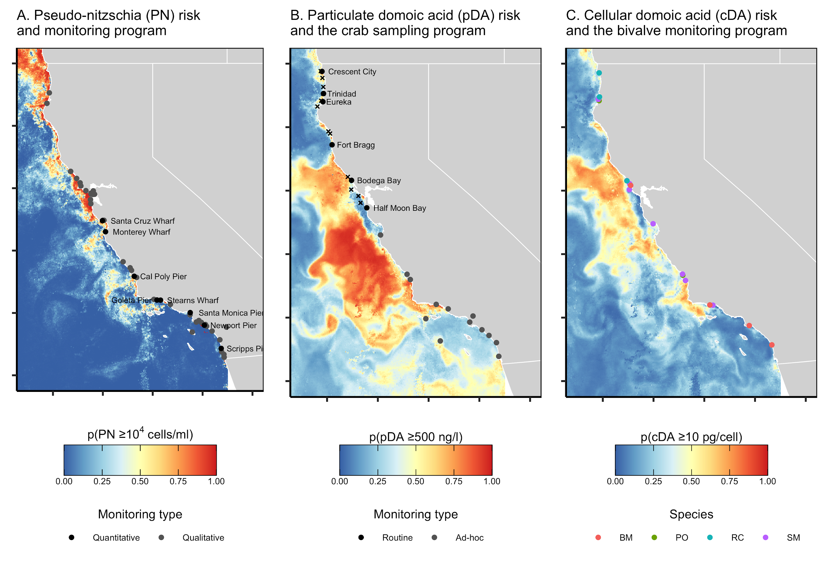

**Figure 1.** Distribution of (A) *Pseudo-nitzschia* (PN), (B) particulate domoic acid (pDA), and (C) cellular domoic acid (cDA) risk predicted by C-HARM on an example date (July 1, 2015). Panel A shows the network of quantitative (8 piers; black circles) and qualitative (40 locations; grey circles) *Pseudo-nitzschia* monitoring sites. Panel B shows the routine pre-season (6 ports, black circles; 2 sites per port, black x’s) and ad-hoc mid-season (13 ports, grey circles) monitoring sites for domoic acid in Dungeness crabs. Panel C shows the routine monitoring sites for domoic acid in bivalves (BM=bay mussel, PO=Pacific oyster; RC=razor clam; SM=sea mussel).

To do list:

1. Italicize *Pseudo-nitzschia*
2. Make bivalve points stand out more prominently
3. Slightly larger legend text
4. Reduce vertical space between legends

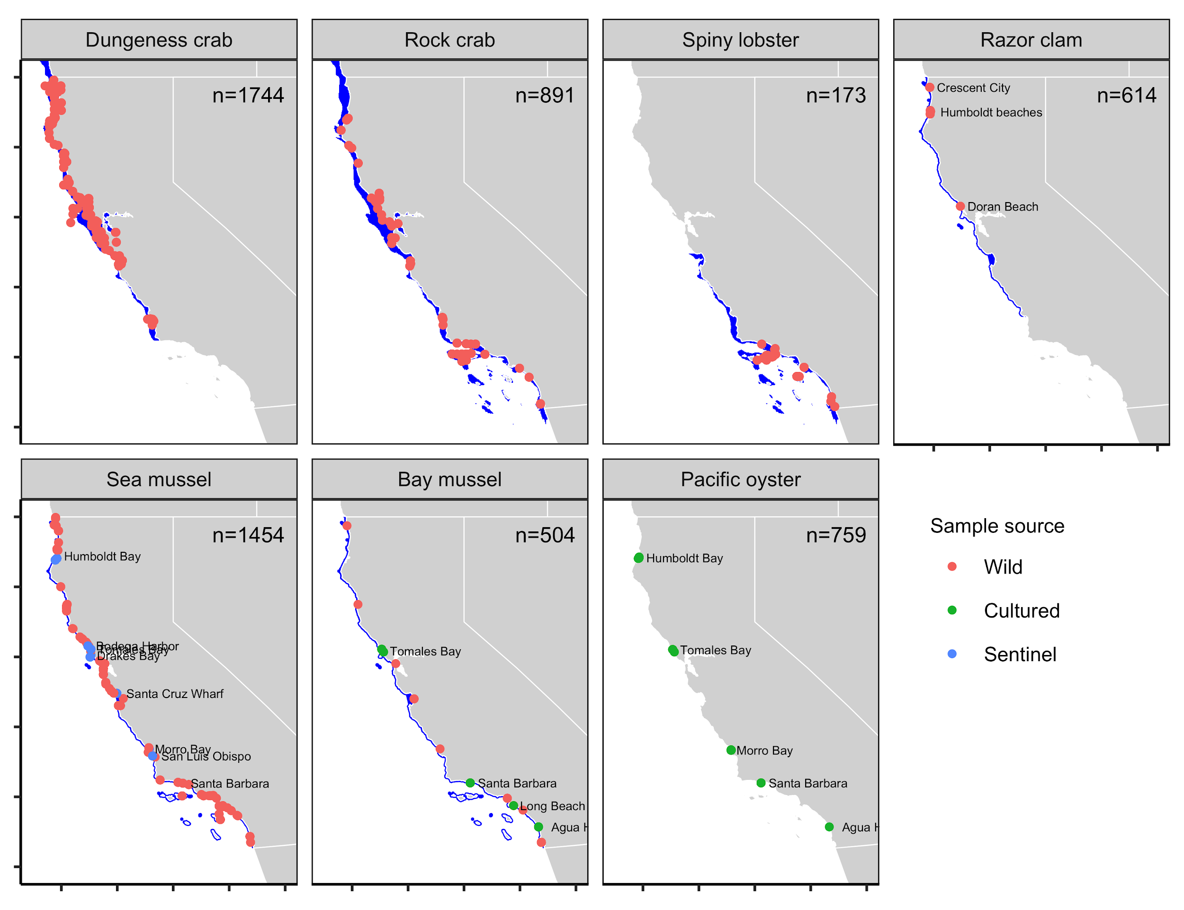

**Figure 2.** The geographical range of the study species (blue shading) in California and the origin of samples collected for domoic acid contamination monitoring. Dungeness crab, rock crab, and spiny lobster mainly occur within 100 fathoms (600 feet) depth; razor clam, sea mussel, and bay mussel mainly occur in intertidal areas; and Pacific oyster only occur at aquaculture farms . The sample size is printed in the top right corner of each plot.

To do list:

1. Make prettier - labels are busy and falling off page
2. Razor clam labels - Crescent Beach, Clam Beach, Doran Beach, Dillon Beach (no monitoring)
3. Add lines and labels showing where distributions end
   1. Dungeness crab - Point Conception
   2. Spiny Lobster - Monterey Bay
   3. Razor clam - Pismo Beach

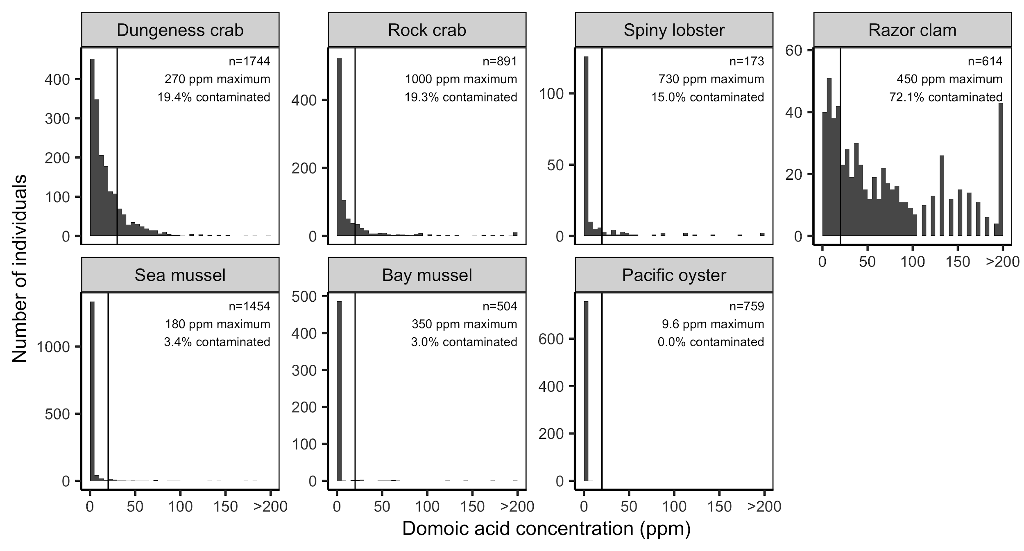

**Figure 3.** Domoic acid concentrations in samples collected by the CDPH as part of its biotoxin monitoring program. The domoic acid FDA action threshold (vertical line) is 30 ppm for Dungeness crab and 20 ppm for all other species. The sample size, percent of samples above the FDA action threshold, and maximum observed concentration are printed in the top right corner of each panel.

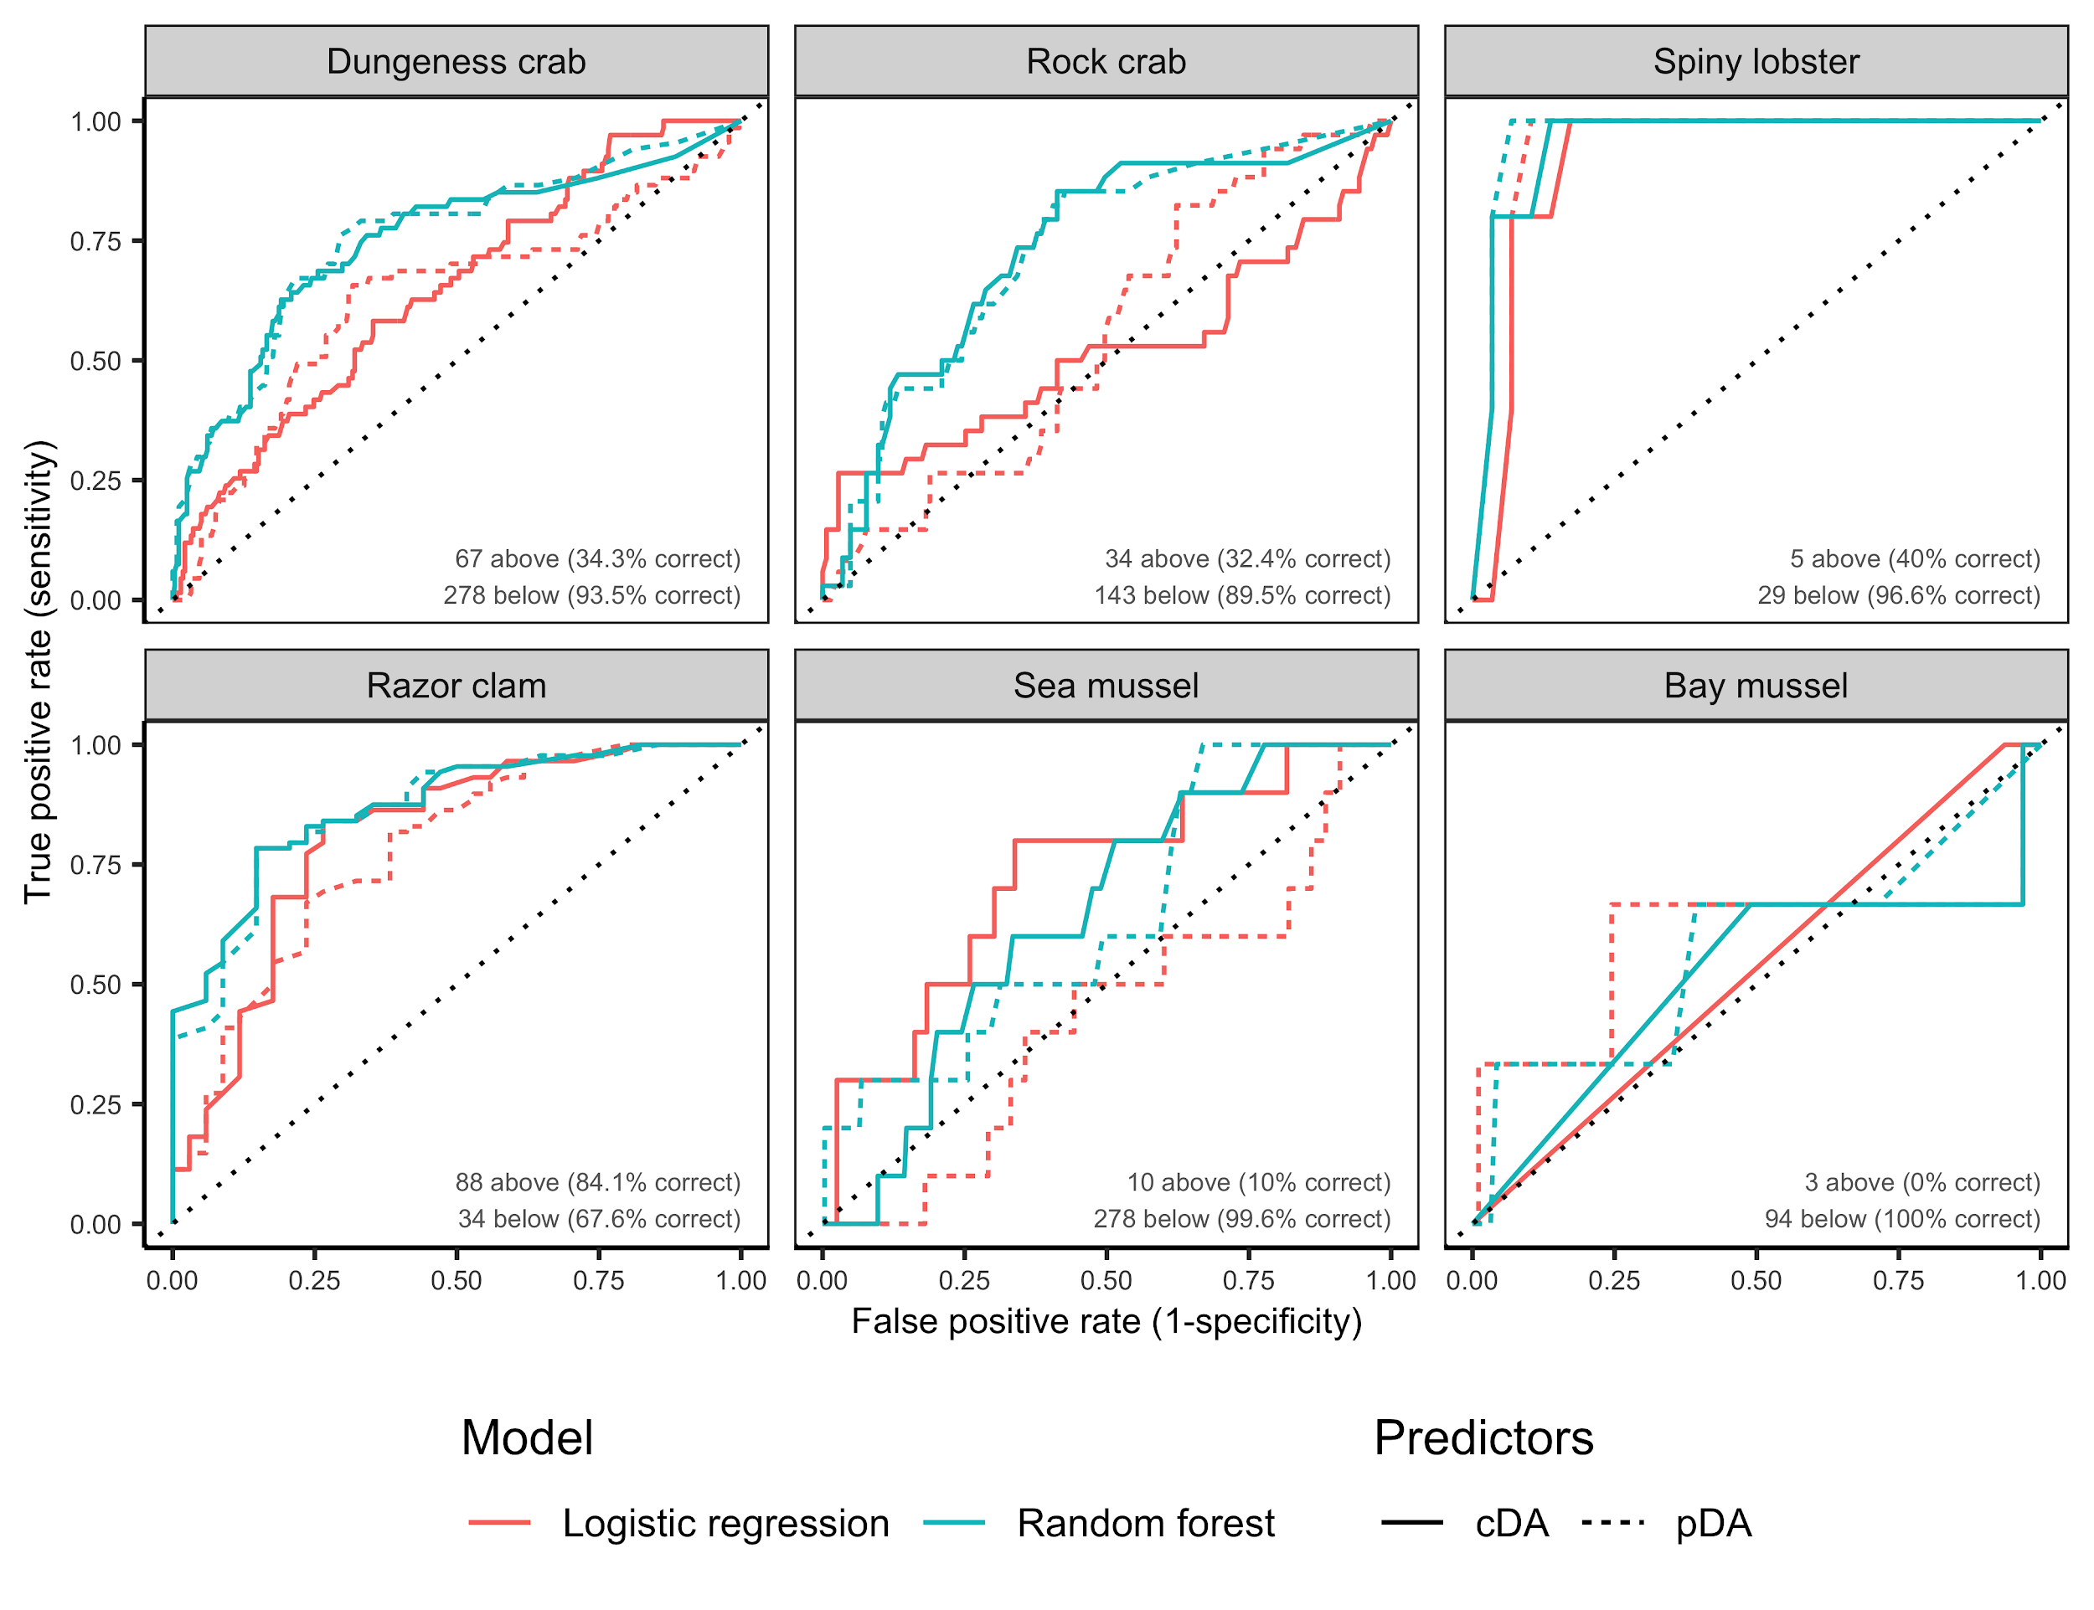

**Figure 4.** Receiver operating characteristic (ROC) curves for logistic regression, random forest, and boosted regression tree models that estimate the probability a crab is contaminated above or below the management action threshold (>30 ppm domoic acid) based on each of the previous 30 days of cDA risk estimated by C-HARM. The best performing model is inundated in the bottom right corner (see **Table S1** for more details). The size of the test dataset and the performance of the best model on the test dataset is indicated in the bottom right corner.

To do list:

* Indicate which model performs best
* Print the performance statistics of the best performing model (its universally the RF pDA model right now)

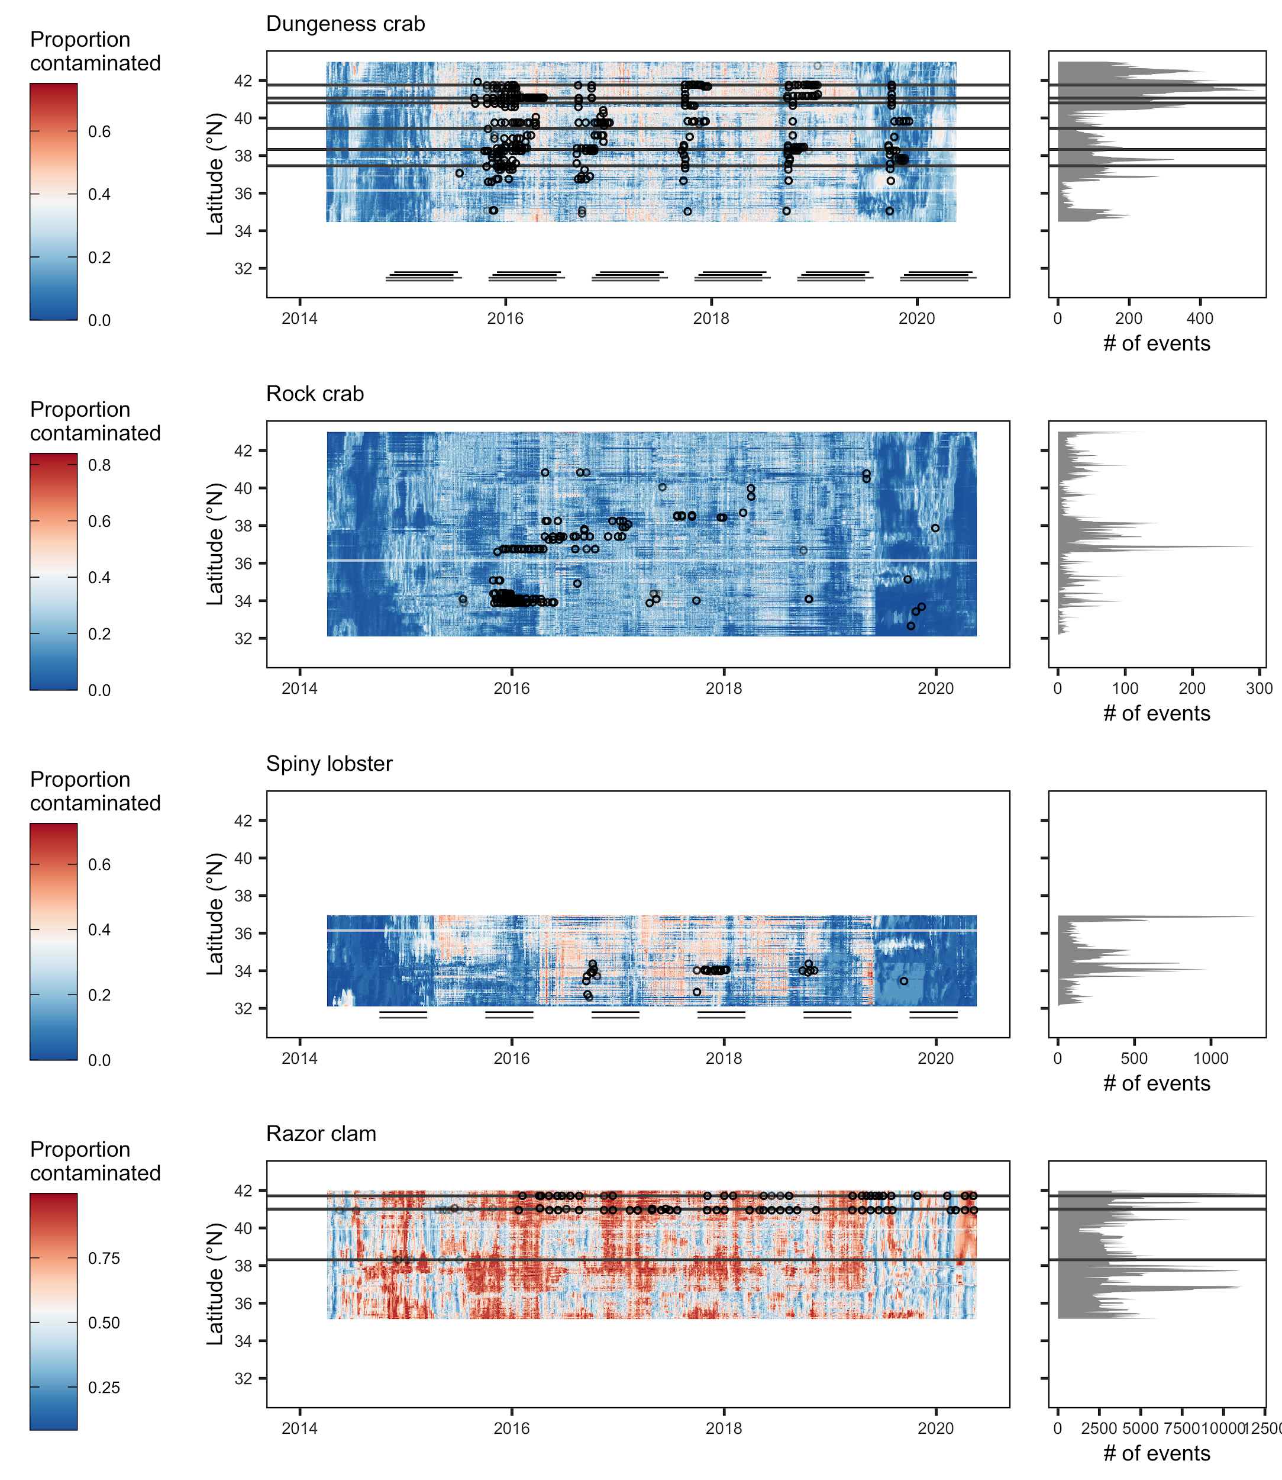

**Figure 5.** Hovmöller diagrams showing the spatial-temporal trends in contamination events within fishing grounds along the California coast. Each cell represents the mean proportion of the population contaminated with domoic acid above the action threshold in all cells in 0.03 degree latitude bans on each day from March 5, 2014 to May 19, 2020 as predicted by the best performing model for each species. Contamination events are identified as events where more than 50% of the population is contaminated with domoic acid above the action threshold (30 ppm for Dungeness crab and 20 ppm for the remaining species). The horizontal lines indicate latitudes with routine sampling programs and the points indicate location and timing of historical sampling.

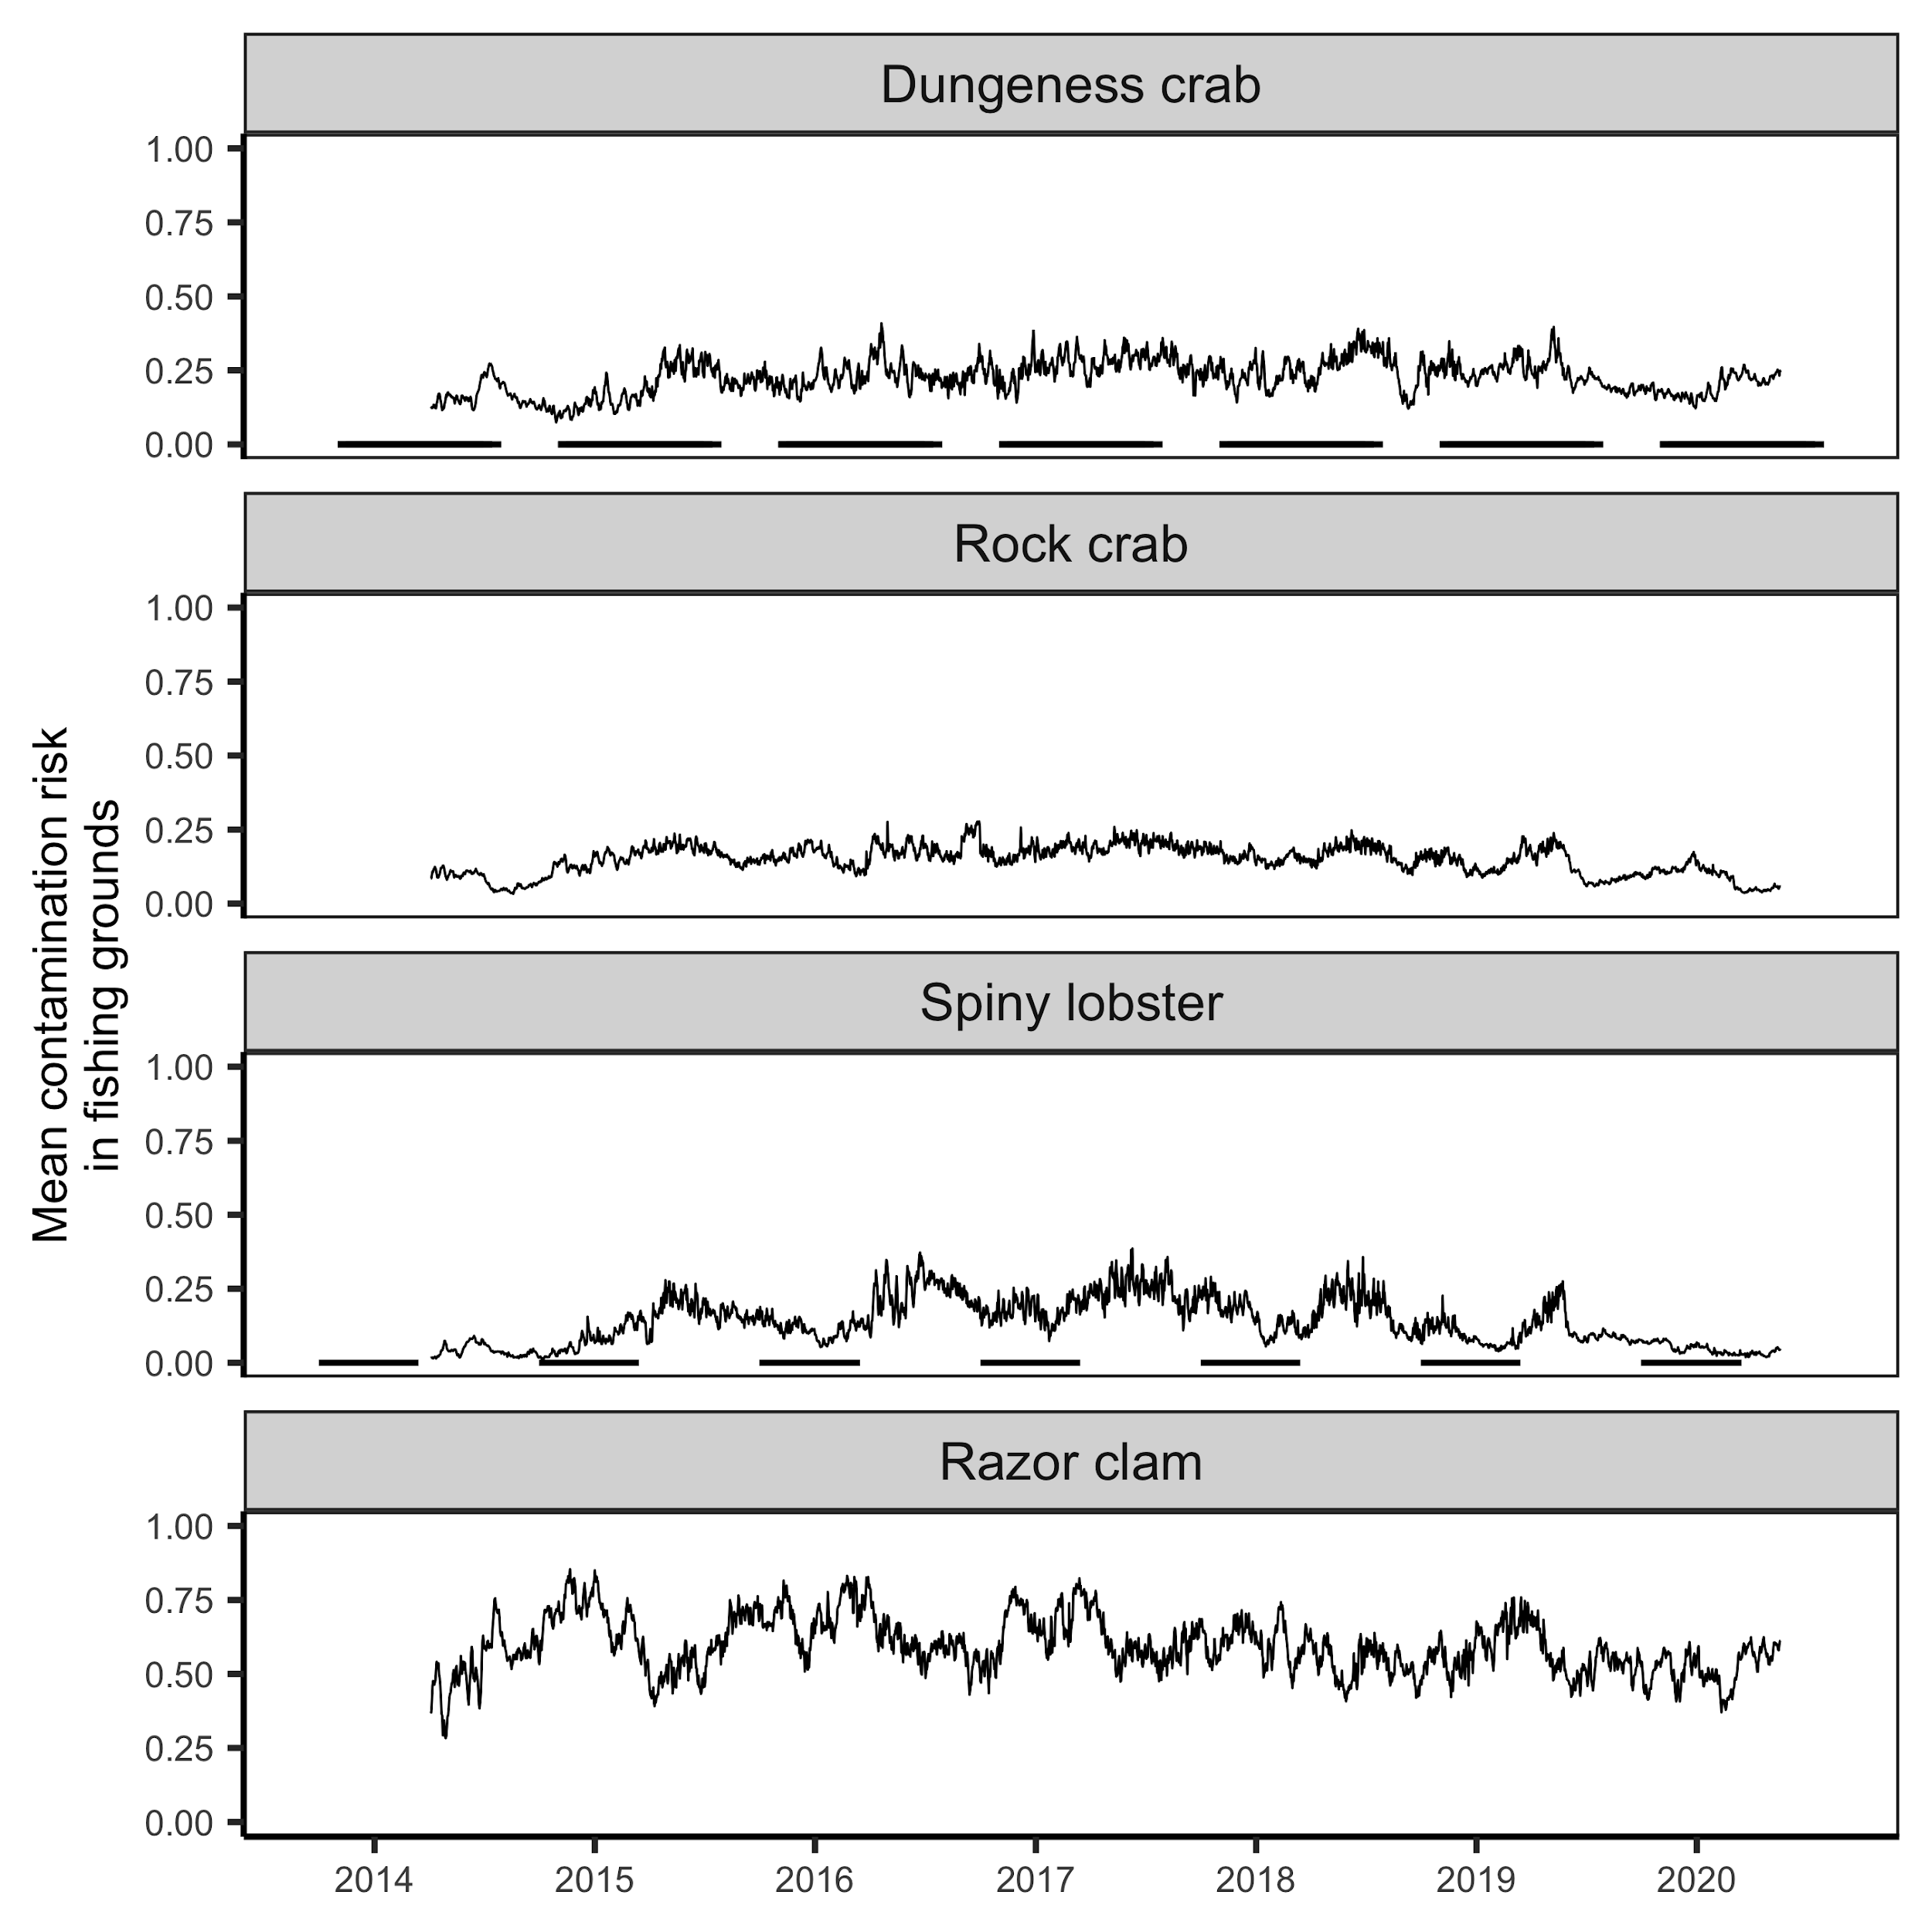

**Figure 6.** Mean daily contamination risk in each species fishing grounds. Lines indicate seasons for Dungeness crab and spiny lobster. Razor clam and rock crab are open year-round.

Coming soon.

**Figure 7.** Histograms showing the distribution in the latitudinal size (in degrees) and duration (days) of contamination events for each of the study species as derived from Figure 7.

## 

## Supplementary material

**Table S1.** Performance metrics for models that estimate the probability that an individual is contaminated above the domoic acid FDA action threshold (30 ppm for Dungeness crab and 20 ppm for all others) based on the previous 30 days of domoic acid risk estimated by C-HARM.*

|  |  |  |  |  |
| --- | --- | --- | --- | --- |
| **Model** | **Predictors** | **AUC** | **Kappa** | **Accuracy** |
| *Dungeness crab* |  |  |  |  |
| **Random forest** | **pDA** | **0.76** | **0.33** | **0.82** |
| Boosted regression trees | pDA | 0.75 | 0.32 | 0.81 |
| Boosted regression trees | cDA | 0.75 | 0.31 | 0.81 |
| Random forest | cDA | 0.75 | 0.33 | 0.82 |
| Logistic regression | cDA | 0.65 | 0.00 | 0.8 |
| Logistic regression | pDA | 0.63 | -0.02 | 0.8 |
| *Rock crab* |  |  |  |  |
| **Boosted regression trees** | **pDA** | **0.73** | **0.24** | **0.76** |
| Random forest | cDA | 0.73 | 0.24 | 0.79 |
| Random forest | pDA | 0.73 | 0.24 | 0.79 |
| Boosted regression trees | cDA | 0.73 | 0.22 | 0.76 |
| Logistic regression | pDA | 0.55 | -0.02 | 0.8 |
| Logistic regression | cDA | 0.52 | 0.17 | 0.81 |
| *Spiny lobster* |  |  |  |  |
| **Random forest** | **pDA** | **0.97** | **0.44** | **0.88** |
| Boosted regression trees | cDA | 0.97 | 0.44 | 0.88 |
| Boosted regression trees | pDA | 0.97 | 0.44 | 0.88 |
| Random forest | cDA | 0.96 | 0.44 | 0.88 |
| Logistic regression | pDA | 0.93 | 0.53 | 0.88 |
| Logistic regression | cDA | 0.92 | 0.53 | 0.88 |
| *Razor clam* |  |  |  |  |
| **Random forest** | **cDA** | **0.87** | **0.52** | **0.8** |
| Boosted regression trees | pDA | 0.86 | 0.50 | 0.8 |
| Random forest | pDA | 0.86 | 0.50 | 0.8 |
| Boosted regression trees | cDA | 0.86 | 0.55 | 0.83 |
| Logistic regression | cDA | 0.81 | 0.45 | 0.79 |
| Logistic regression | pDA | 0.78 | 0.40 | 0.78 |
| *Sea mussel* |  |  |  |  |
| **Logistic regression** | **cDA** | **0.72** | **-0.01** | **0.96** |
| Random forest | cDA | 0.64 | -0.01 | 0.96 |
| Random forest | pDA | 0.64 | 0.16 | 0.97 |
| Boosted regression trees | pDA | 0.62 | -0.01 | 0.96 |
| Boosted regression trees | cDA | 0.62 | 0.16 | 0.97 |
| Logistic regression | pDA | 0.43 | -0.02 | 0.95 |
| *Bay mussel* |  |  |  |  |
| **Logistic regression** | **pDA** | **0.59** | **0.26** | **0.95** |
| Random forest | pDA | 0.58 | 0.00 | 0.97 |
| Logistic regression | cDA | 0.53 | -0.04 | 0.91 |
| Random forest | cDA | 0.51 | 0.00 | 0.97 |
| Boosted regression trees | pDA | 0.5 | 0.00 | 0.97 |
| Boosted regression trees | cDA | 0.47 | 0.00 | 0.97 |

* pDA=particulate domoic acid; cDA=cellular domoic acid; AUC=area under the receiver operating curve

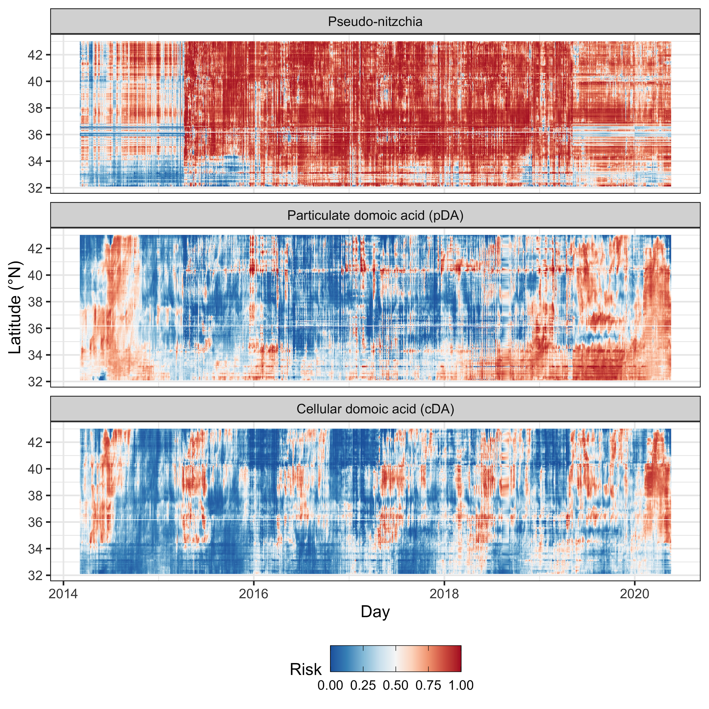

**Figure S1.** Hovmöller diagrams showing the spatial-temporal trends in mean *Pseudo-nitzschia*, particulate domoic acid (pDA), and cellular domoic acid (cDA) risk inside California fishing grounds (waters less than 100 fathoms) as predicted by C-HARM from 2014 to 2019.

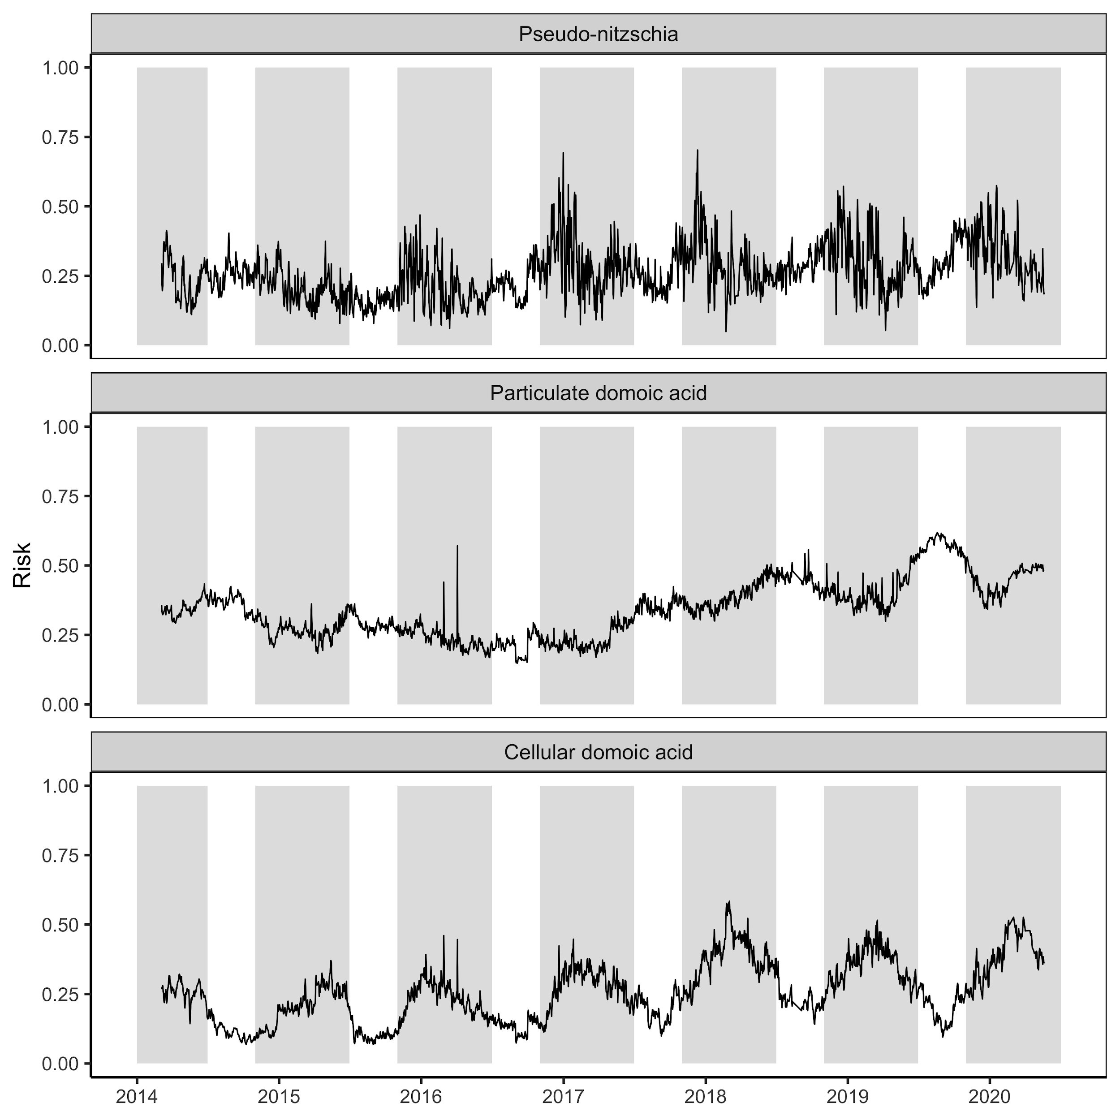**Figure S2.** The mean *Pseudo-nitzschia*, particulate domoic acid (pDA), and cellular domoic acid (cDA) risk predicted by C-HARM from 2014 to 2019 on the California shelf (<100 fathoms). Dungeness crab commercial fishing seasons are shaded in grey.

To do list:

1. Add line for whole domain and line for fishing grounds

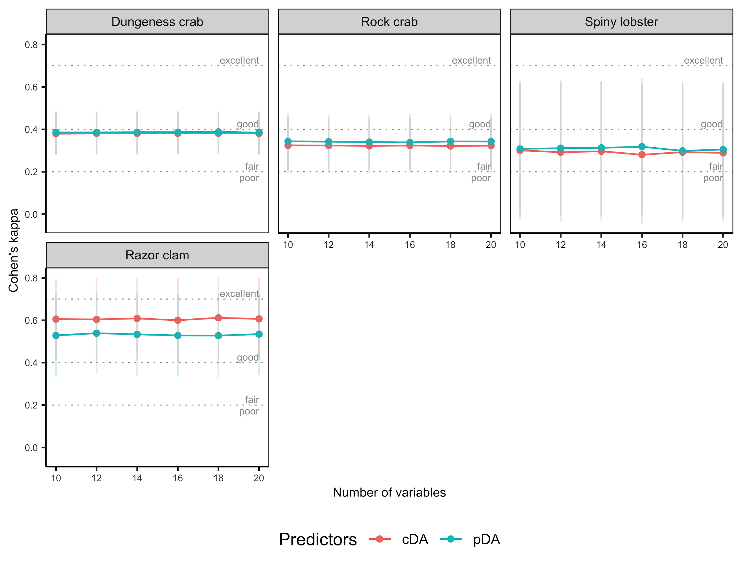**Figure S3.** Performance of candidate random forest classification models used to estimate the probability that an individual organism is contaminated with domoic acid above its FDA action threshold. The candidate models consider two sets of predictors - particulate domoic acid (pDA) and cellular domoic acid (cDA) -- and six levels of the hyperparameter ("mtry") controlling the number of random variables at each split in the model. Performance is measured through 10-fold cross-validation using Cohen’s kappa which measures the proportion of correct classifications accounting for the probability of being correct by chance. Although there are no definitive rules for interpreting Cohen’s kappa, general guidelines suggest that values >0.70 are ‘excellent’, 0.4–0.7 are ‘good’, 0.2–0.4 are ‘fair’, and <0.2 are ‘poor’.

To do list:

1. This appears to be missing species
2. Increase size of axis text

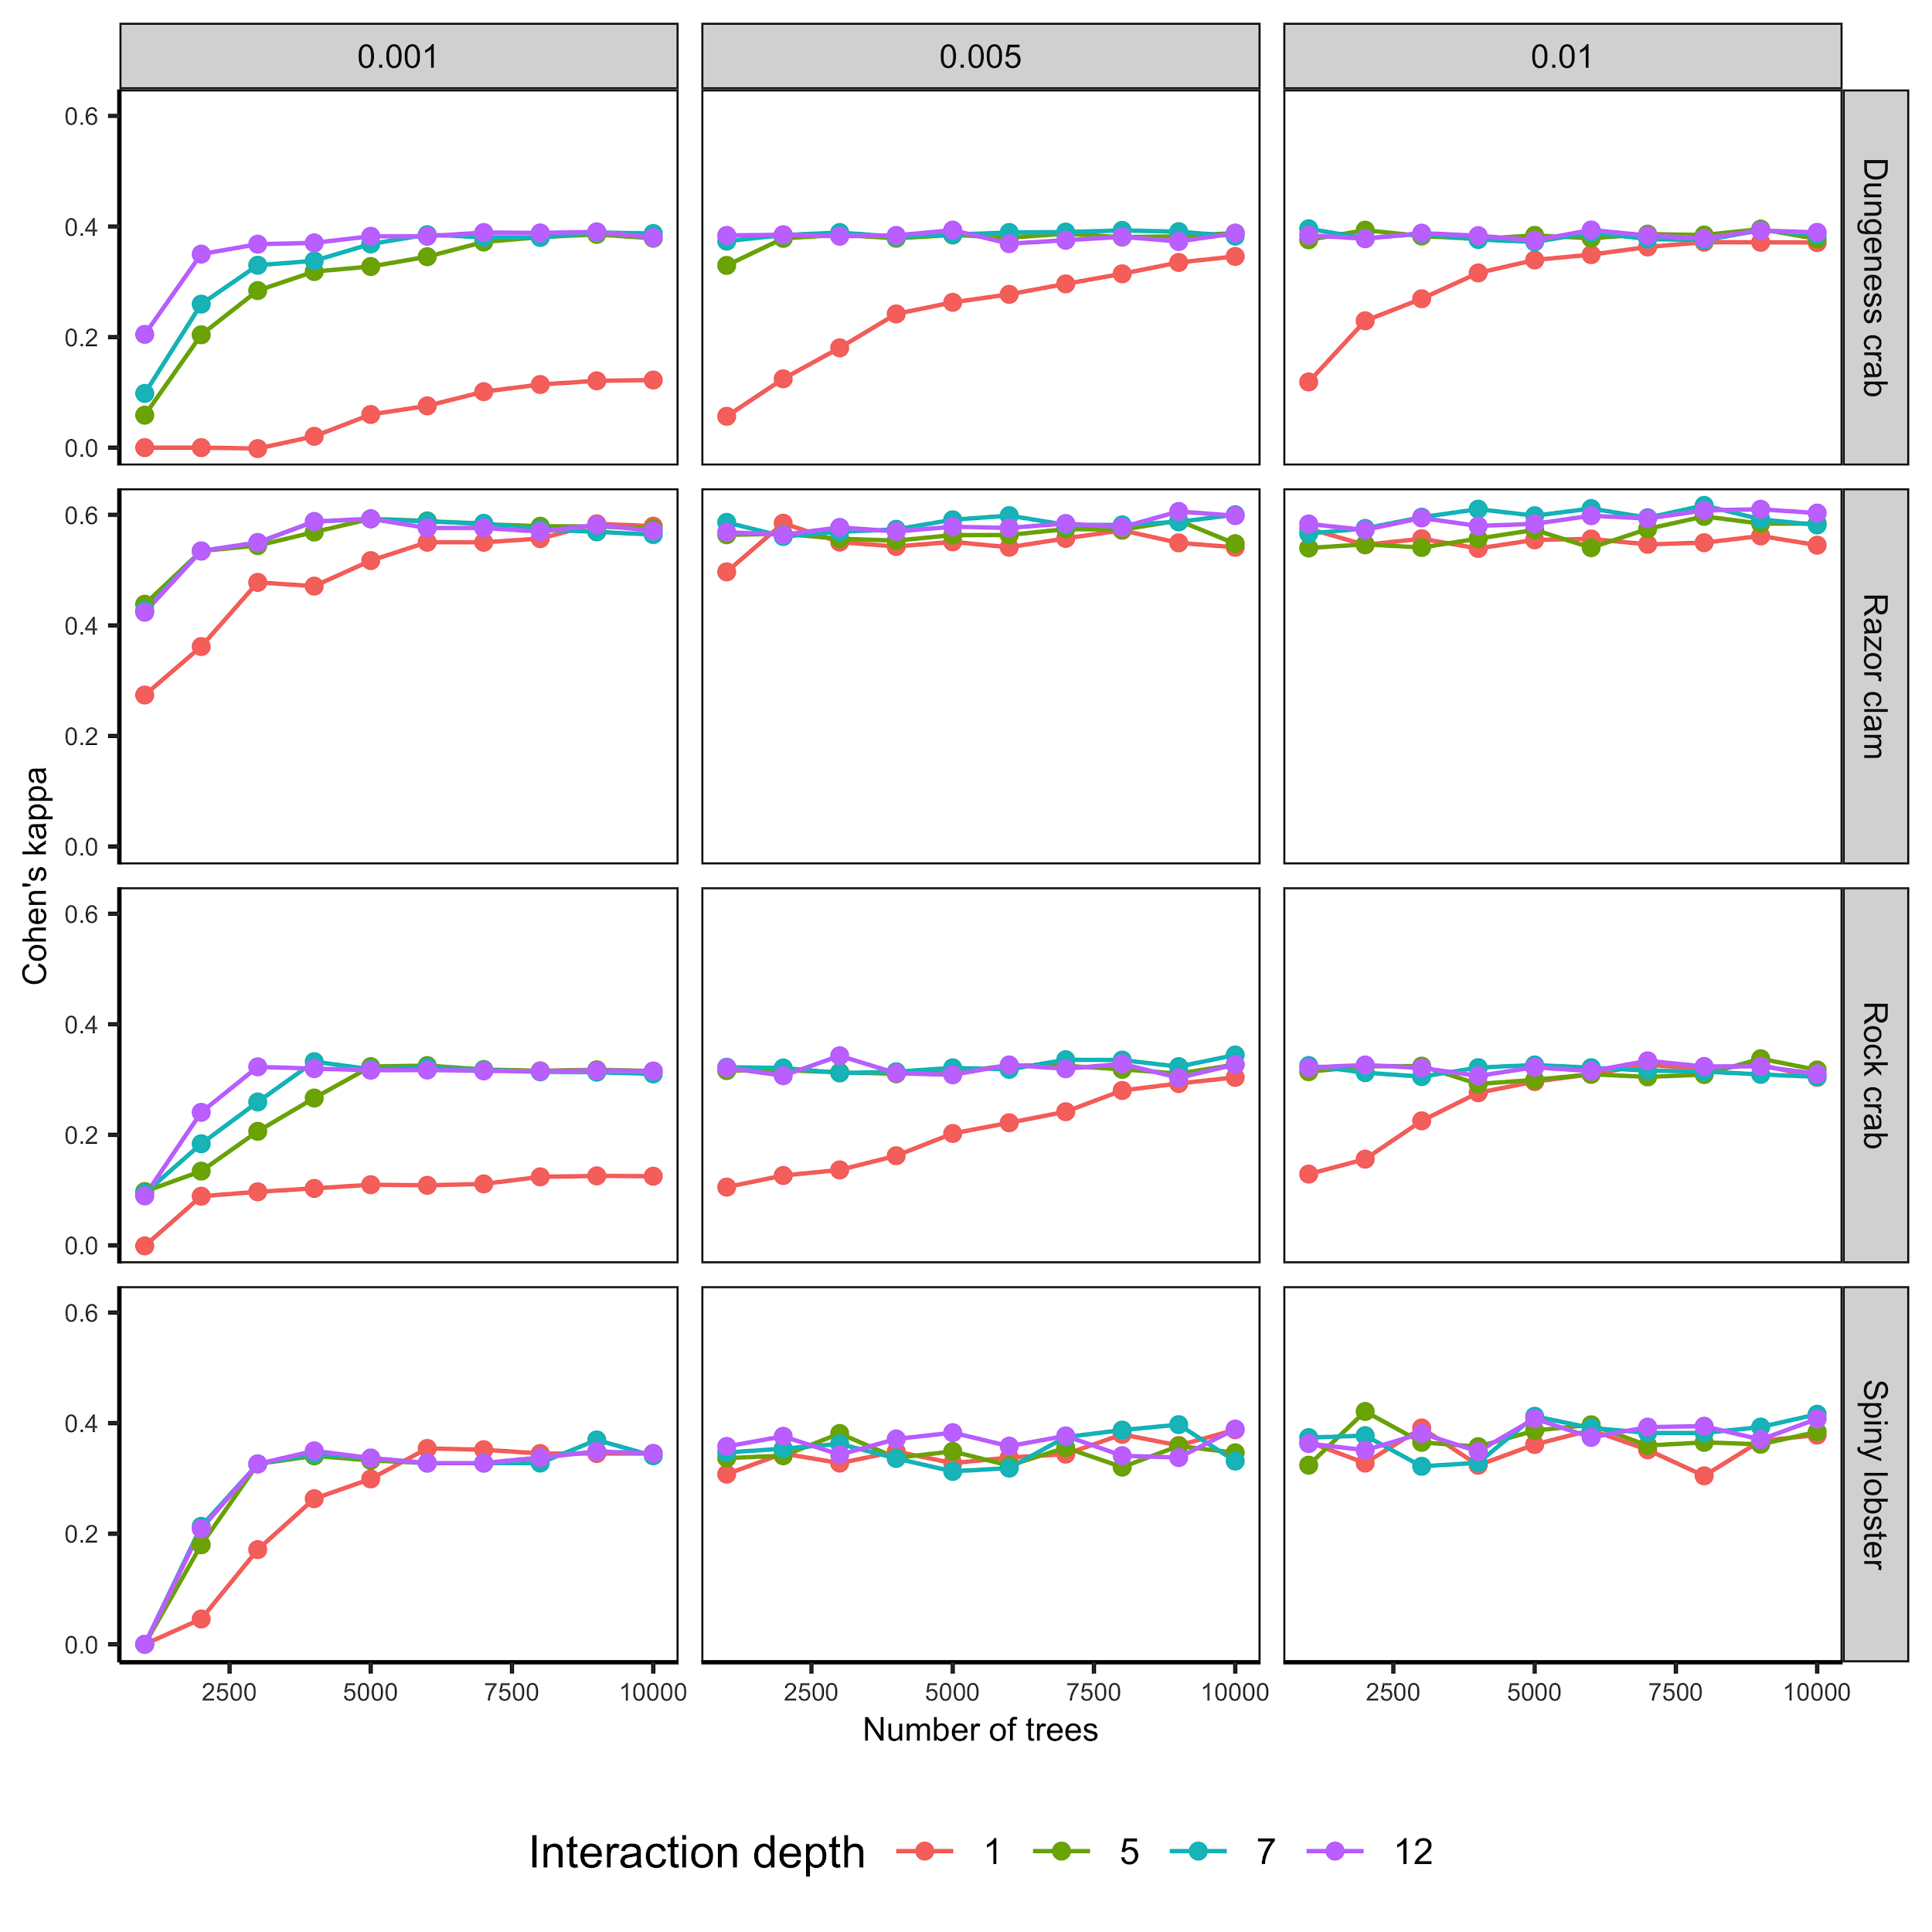

**Figure S4.** Performance of candidate boosted regression tree classification models used to estimate the probability that an individual organism is contaminated with domoic acid above its FDA action threshold. The candidate models consider two sets of predictors - particulate domoic acid (pDA) and cellular domoic acid (cDA) -- and six levels of the hyperparameter ("mtry") controlling the number of random variables at each split in the model. Performance is measured through 10-fold cross-validation using Cohen’s kappa which measures the proportion of correct classifications accounting for the probability of being correct by chance. Although there are no definitive rules for interpreting Cohen’s kappa, general guidelines suggest that values >0.70 are ‘excellent’, 0.4–0.7 are ‘good’, 0.2–0.4 are ‘fair’, and <0.2 are ‘poor’.

One plot for cDA, one for pDA, fix caption, add Kappa lines; missing species

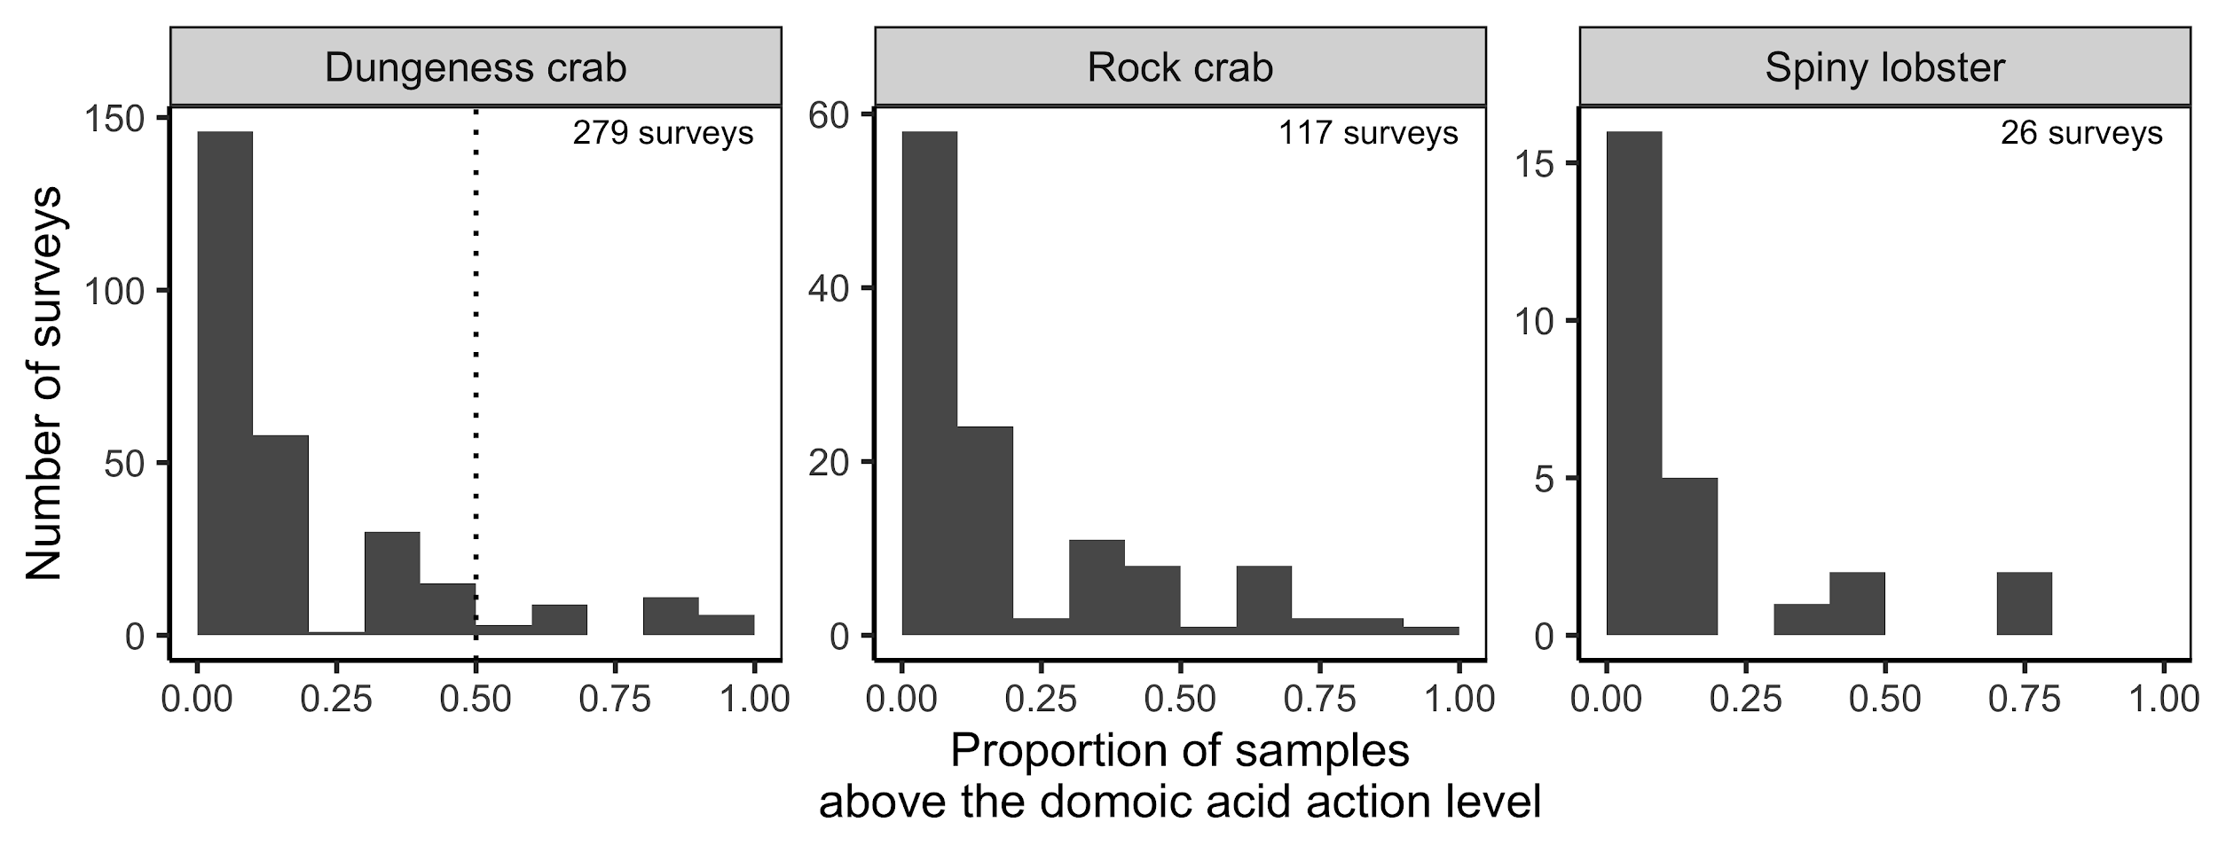

**Figure S5.** Distribution of the proportion of samples collected in individual surveys above the domoic acid action threshold (30 ppm for Dungeness crab and 20 ppm for rock crab and spiny lobster). A space-time closure is triggered if a pre-season survey reveals that 50% of Dungeness crabs (vertical dotted line) are contaminated above the 30 ppm action threshold.